PRT661 – Data Science Practice
Australian Electricity Demand Forecasting
WP4 Final Modelling Analysis, Deep Learning Evaluation and Production Model Selection
Table 1. Dan6 – Theme 2 (Group 2) team and responsibilities
Student | ID | Earlier stages (WP1–WP3) | WP4 role
Ashish Shrestha | S388084 | Feature engineering, Random Forest A/B, backtesting, selection | MLP implementation; overall model-selection integration
Bishal Dahal | S388095 | Validation, baselines, metrics, evidence figures | Independent MLP validation; expanded metrics and evidence
Suraj Raut | S391201 | Timestamp harmonisation, XGBoost, recursive engine | GRU sequence preparation and recursive engine
Sudip Lamichhane | S388085 | WA acquisition, source quality, SARIMA/SARIMAX, weather provenance | GRU training controls, information boundaries, provenance

Table 2. Evidence basis of this report
Item | Value
Evidence basis | Full academic run of Energy_Demand_Forecasting_Pipeline.py v4.0.0 (EnergyForecast_Run_20260929_145931), status COMPLETE
Run scope | 6 regions × 4 historical origins = 24 region-years; 10 registry models + 2 non-selection experiments; 288 model runs (274 successful, 14 failed)
Run time and environment | 426.7 minutes on an 8-core Windows 11 CPU (no GPU); Python 3.13.2; TensorFlow 2.21.0; seed 20260914
Data | Stage 1 extraction to 14 Sep 2026; demand from 1 Jan 2022; 162/162 Stage 2 core checks PASS
Report date | 29 September 2026

Contents
1. Executive Summary
2. Project Development from WP3 to WP4
3. Lecturer/Project Feedback and Response
4. Updated Modelling Architecture
5. Data and Historical Backtesting
6. Preprocessing and Feature Engineering
7. Leakage-Safe Experimental Design
8. Original Eight Models
9. MLP Neural Network Addition
10. GRU Deep-Learning Addition
11. Ten-Model Experimental Framework
12. Overall Performance
13. Regional Performance
14. Previous Champion vs MLP vs GRU
15. Historical-Year Stability
16. Monthly Stability
17. Forecast-Horizon Analysis
18. Weather Contribution
19. Feature Set A vs B
20. Peak-Demand Analysis
21. Residual/Error Analysis
22. Explainability
23. Statistical Comparison
24. Computational Cost
25. Regional Winner Selection
26. Common vs Regional vs Hybrid Strategy
27. Final Model Retention
28. Non-Technical Interpretation
29. Team Collaboration
30. Production/Web-Portal Recommendation
31. Limitations
32. Next Phase
33. Conclusion
References
Appendix A – Evidence Register
Appendix B – Supplementary Tables
Appendix C – Supplementary Figures and Output Inventory

1. Executive Summary
WP3 ended with a defensible forecasting baseline: an eight-model comparison on matched four-month historical windows selected Random Forest in all six regions. The feedback that followed asked for stronger modelling exploration, specifically a neural and deep-learning investigation. WP4 answered that request without discarding what already worked. The preprocessing, feature engineering and eight previous models were consolidated into one leakage-safe application, a Multilayer Perceptron (MLP) and a Gated Recurrent Unit (GRU) network were added, the backtest was widened to every valid September–December window from 2022 to 2025, and the evidence base was expanded with normalised, horizon, peak, residual, stability, statistical and cost analyses.
The full run completed for all 6 regions and all 10 registry models. Selection used the three full-history origins (1 September 2023, 2024 and 2025); the 2022 window, which has no earlier September–December history, was run and reported as a limited-history warm-up but excluded from the decision. The result is unambiguous at the family level and deliberately cautious at the configuration level.
Decision
Retain the Random Forest family. RandomForest_A (39 demand/calendar/history features) is retained for NSW1, QLD1, VIC1 and TAS1; RandomForest_B (54 features, adding origin-safe weather) is retained for SA1 and WA.
Neither neural model improved on the strongest previous model in any region. The MLP was 3.0–23.5% worse in mean four-month MAE and the GRU 3.2–26.4% worse. The nearest result was WA, where the MLP was runner-up, 3.0% behind RandomForest_B. The GRU also required roughly 25 times the compute of a Random Forest fit.
Only the six selected Random Forest artefacts move toward the web portal. MLP, GRU, XGBoost, SARIMA, SARIMAX and the naive baselines remain in the research repository as evidence.

Two qualifications matter. First, the margin between RandomForest_A and RandomForest_B is small in several regions (1.0–2.6% in NSW1, VIC1, SA1 and TAS1) and not statistically significant there, so the A/B choice is a region-level configuration detail rather than a strong scientific claim; one Random Forest code path with two feature schemas serves both. Second, all models under-forecast peak demand, which is the most important weakness to carry into the production phase.
The academic contribution of WP4 is therefore not that deep learning won. It is that a more complex method was implemented properly, tested on the same held-out windows with the same information limits, and rejected on out-of-sample evidence — while the development history, failures and weaker models remain visible.

2. Project Development from WP3 to WP4
The project was built as a three-stage handoff. Stage 1 (WP1) acquires half-hourly and five-minute operational demand for NSW1, QLD1, VIC1, SA1 and TAS1 from AEMO, WA demand from the WEM (with genuine 30-minute legacy and five-minute modern regimes), ERA5 historical weather, a rolling seven-day forecast-weather vintage and public holidays. The Northern Territory was removed from Assessment 1 scope because no reproducible automated historical feed was established. Stage 2 (WP2) removes duplicates, detects source resolution, interpolates only gaps of two intervals or fewer, flags (never deletes) extreme values, harmonises to a 30-minute grid, resolves market and civil clocks and builds Feature Sets A and B. Stage 3 (WP3) screened eight models, backtested them over four-month windows and selected one model per region.
WP3 selected RandomForest_A for NSW1, QLD1, VIC1 and TAS1 and RandomForest_B for SA1 and WA, then verified a frozen September–December 2026 forecast against 3,765 September intervals (pooled MAE 207.3 MW). The Meeting 6 minutes of 15 September 2026 record SA1 under Model A, which conflicts with the WP3 report; the WP4 evidence resolves the point in favour of RandomForest_B for SA1, with a margin of 1.6% that is not statistically significant (Section 25).
Table 3. WP3 versus WP4 selection on the same three September origins (mean four-month MAE)
Region | WP3 selection | WP3 MAE (MW) | WP4 selection | WP4 MAE (MW) | Change
NSW1 | RandomForest_A | 596.8 | RandomForest_A | 604.8 | +1.3%
QLD1 | RandomForest_A | 439.1 | RandomForest_A | 438.2 | −0.2%
VIC1 | RandomForest_A | 458.2 | RandomForest_A | 457.1 | −0.2%
SA1 | RandomForest_B | 183.1 | RandomForest_B | 186.4 | +1.8%
TAS1 | RandomForest_A | 70.2 | RandomForest_A | 70.9 | +1.0%
WA | RandomForest_B | 206.5 | RandomForest_B | 204.5 | −1.0%

The regional selections are identical and the MAE values move by at most 1.8%. The small shifts are expected: WP4 re-derives the heating/cooling balance point separately for every origin (a leakage correction), rebuilds profiles inside one engine and no longer pre-screens models. Stability of the decision under these corrections is itself useful evidence.

2.1 Forensic comparison of the two modelling implementations
The previous file (Modelling_Progress_Decision_Updated.py) consumed a Stage 2 ZIP and ran eight models; the WP4 file (Energy_Demand_Forecasting_Pipeline.py v4.0.0) runs acquisition-to-selection in one application. Table 4 records what was preserved and what changed.
Table 4. Previous versus WP4 implementation
Area | Previous implementation | WP4 implementation | Reason for change | Academic benefit | Evidence source
Models | 8: Naive48/336, RF A/B, XGB A/B, SARIMA, SARIMAX | Same 8 unchanged + MLP + GRU (10); GRU_L672 and XGB A+core weather as non-selection experiments | Lecturer/project feedback: explore neural and deep learning | Neural claim tested, not assumed | MODEL_REGISTRY; model_registry.csv
Hyper-parameters | RF 150 trees depth 18; XGB 700 trees depth 8; SARIMA (1,0,1)(1,0,0,48) | Identical values, now in a configuration block | Preserve comparability with WP3 | Old and new results comparable | RF_/XGB_/SARIMA_PARAMETERS
Features | Set A 39, Set B 54 | Unchanged; demand features proven identical to Stage 2 (max diff 0.0 MW) | Do not redefine a model under the same name | Continuity of the A/B experiment | demand_feature_equivalence.csv
Pipeline | Separate Stage 2 and Stage 3 scripts and ZIP handoff | One GUI/CLI application, one run folder | Stage 2/3 config-key mismatch found in Phase 1 audit | One reproducible execution | run_environment.json
Backtest origins | Analogue origins capped at 3 (2023–2025) | 2022 (limited, reported) + 2023–2025 (selection) | Use all history from 2022 | Warm-up robustness evidence | backtest_origins.csv
Balance point | Stage 2 column derived from years before the production year | Re-derived per origin from pre-origin days only | Later backtest years leaked into earlier origins | Leakage removed | origin_feature_rebuild_checks.csv
Screening | 6 models × 3 folds × 14 days gated the backtest | Removed; every model reaches every origin | Screen overlapped Nov–Dec 2025 test window | Fairer comparison | leakage_audit.csv
Metrics | MAE, RMSE, sMAPE, Bias, MedAE, skill | + nMAE, R², MASE, lead bands, peak, residual, stability, DM tests, runtime | Cross-region and multi-angle evidence | Selection not based on one number | metrics/*.csv
Selection | Mean MAE, 1% tie, complexity tie-break | Mean MAE, 1% tie, declared sequential tie-break chain; common-model analysis | Transparency; portal strategy question | Auditable trace | selection_trace.txt
Outputs | Forecast vintages, AEMO benchmark | Interval detail for every model, 107 figures, selected-model artefacts; AEMO benchmark left to portal phase | Evidence for later interpretation | Re-analysable without retraining | forecasts/, figures/

3. Lecturer/Project Feedback and Response
After WP3 the team received feedback that the modelling should explore stronger methods, in particular neural and deep-learning approaches, rather than stopping at tree ensembles and classical baselines. The feedback was recorded as a project direction rather than a quotation; this report does not reproduce wording that is not in the supplied evidence. WP3 had itself listed deep learning as a stretch item. The response was designed so the outcome could go either way: the neural models were added to the same registry, trained only on information available at each origin, and judged by the same rule as every other model.
Table 5. Feedback and WP4 response
Feedback theme | WP4 response | Evidence
Explore neural / deep-learning models | MLP on engineered features; GRU on 336-step demand sequences with known-future inputs; 672-step sensitivity | neural_vs_previous_comparison.csv; N01–N03
Make the comparison fair | Same origins, same recursion, same climatology weather, training-only scaling, chronological validation | information_availability.csv; leakage_audit.csv
Strengthen the experiment | Four origins incl. 2022 warm-up; balance-point fix; screening gate removed | backtest_origins.csv; origin_feature_rebuild_checks.csv
Strengthen the evidence | nMAE, horizon bands, peak, residual, stability, DM, runtime, common-model penalty | metrics/ folder (19 CSVs)
Keep earlier work visible | All 8 previous models preserved with unchanged parameters | model_registry.csv

4. Updated Modelling Architecture
The integrated application separates research from production. On the research side every model is trained and scored; on the production side only the retained artefacts are loaded. Figure 1 shows the architecture updated to the actual WP4 result: MLP and GRU sit inside the ten-model experiment and do not appear in the production path because they were not selected.
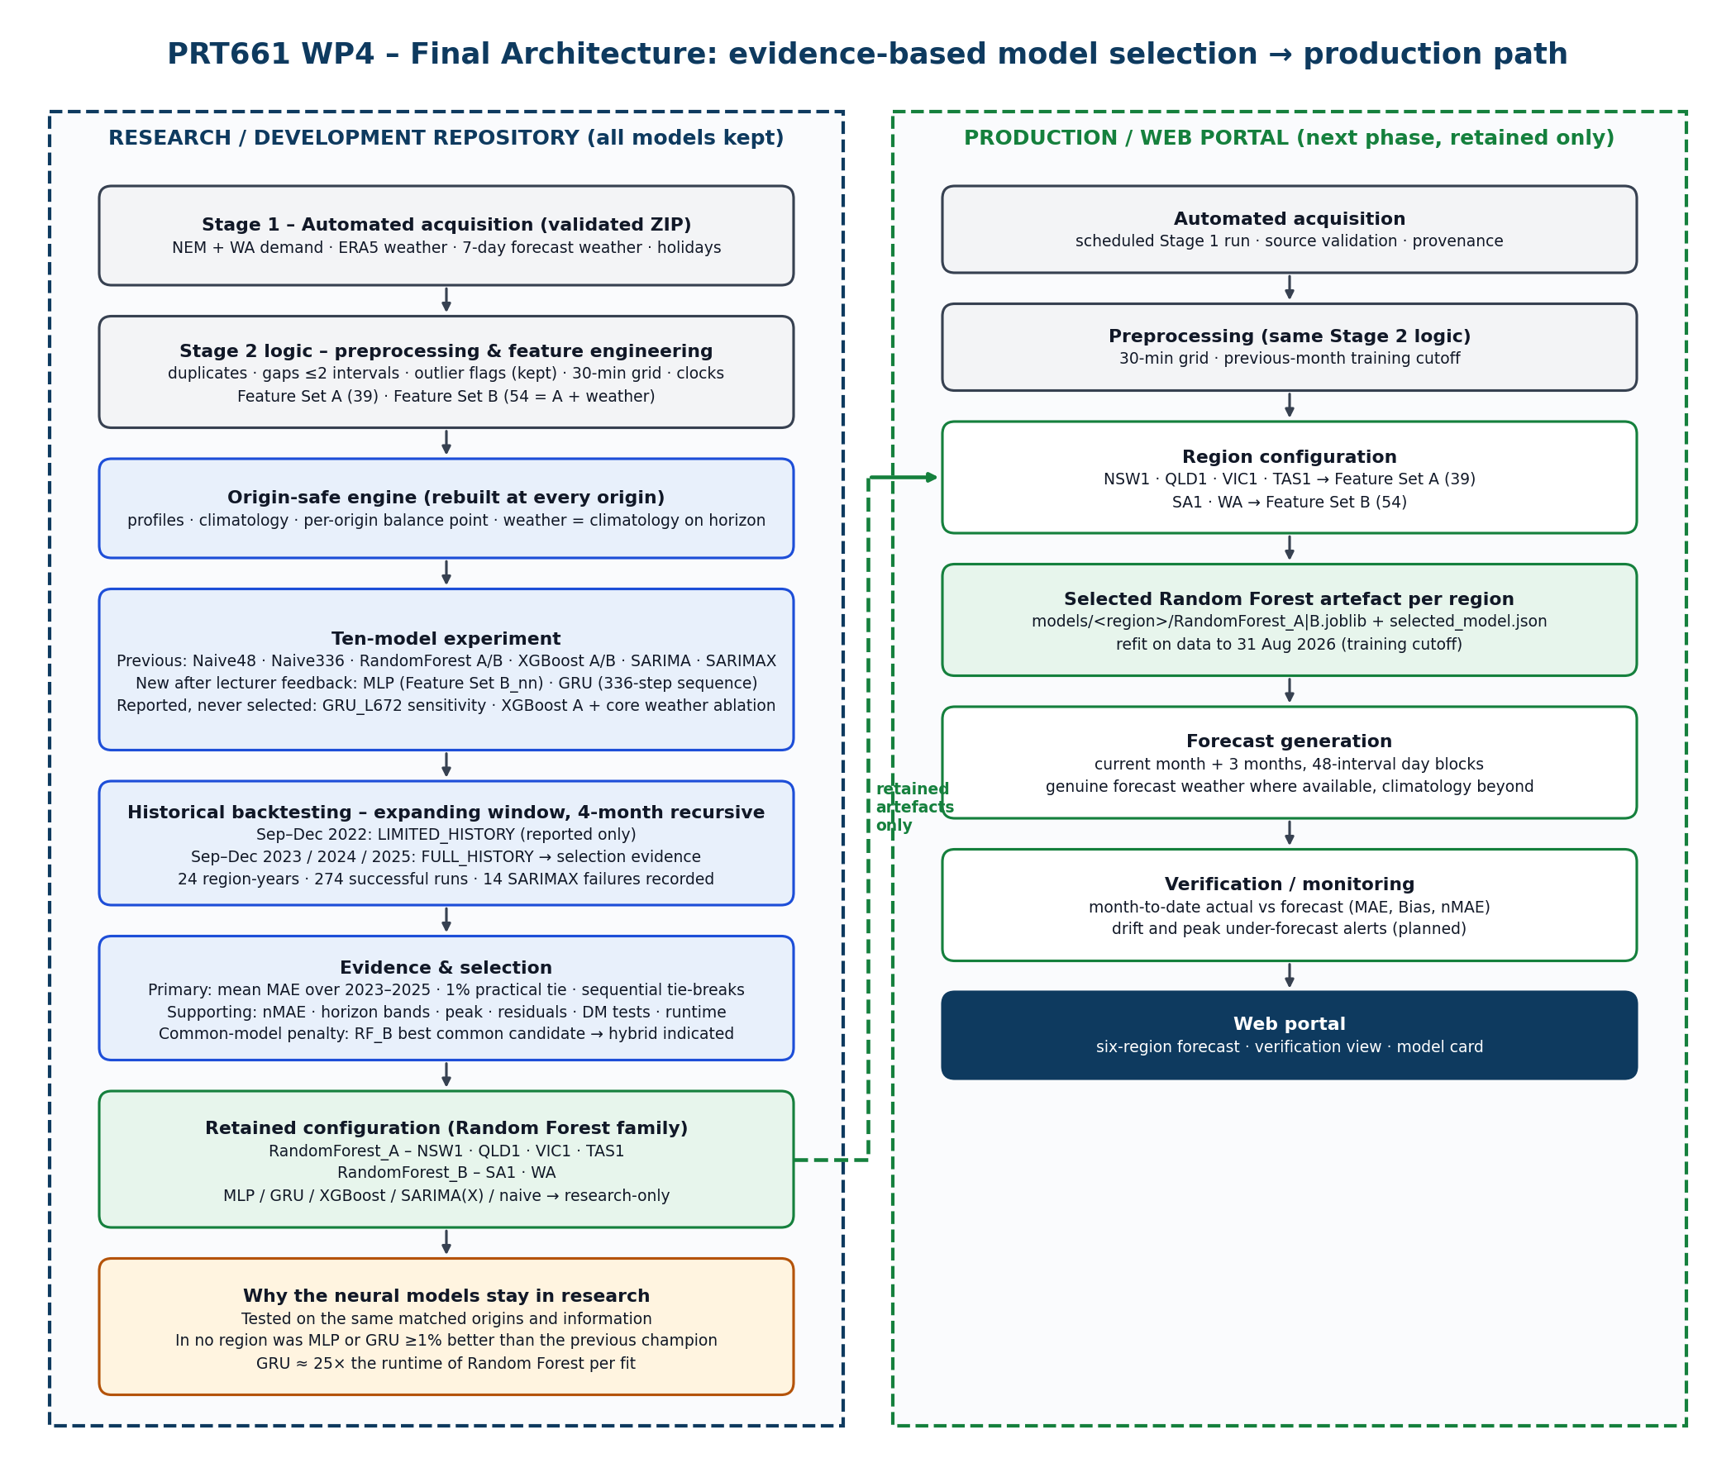
Figure 1. WP4 final architecture. Research/development (left) keeps all models as evidence; the production path (right) loads only the selected Random Forest artefacts.
Operationally the application is one Python file with a Tkinter interface (dataset and output selection, run options, progress, cancellable worker thread) and a command-line mode. Each run writes a timestamped folder with validation, forecasts, metrics, figures, models, logs, environment and summary sub-folders, so every claim in this report can be traced to a file (Appendix A).

5. Data and Historical Backtesting
The Stage 1 extraction covers 1 January 2022 to 14 September 2026 for all six regions, with weather to 9 September 2026 and holidays to 31 December 2026. All 162 Stage 2 core checks passed. WA contains 16 half-hours without demand at the October 2023 market transition; they are excluded from training and scoring rather than filled. SA1 contains 1,168 five-minute readings at or below 0 MW caused by rooftop solar; they are genuine operational demand and are kept.
Backtesting follows chronological model development. For each year the models are trained on every observation before 1 September and forecast 1 September to 31 December recursively: 122 days, or 5,856 half-hours, with no retraining and no access to actual demand after the origin.
Table 6. Historical backtest origins (validation/backtest_origins.csv)
Backtest | Training history | Days before origin | Origin type | Used for selection | Regions valid
Sep–Dec 2022 | Jan–Aug 2022 | 242 | LIMITED_HISTORY_BACKTEST | No (reported) | 6 / 6
Sep–Dec 2023 | Jan 2022 – Aug 2023 | 607 | FULL_HISTORY_BACKTEST | Yes | 6 / 6
Sep–Dec 2024 | Jan 2022 – Aug 2024 | 973 | FULL_HISTORY_BACKTEST | Yes | 6 / 6
Sep–Dec 2025 | Jan 2022 – Aug 2025 | 1,338 | FULL_HISTORY_BACKTEST | Yes | 6 / 6

The 2022 origin cannot be treated like the others. There is no 2021 data and therefore no earlier September–December history: the historical month profiles for the horizon months and the day-of-year weather climatology simply do not exist before 1 September 2022. The models still run, but the missing horizon features are filled from training medians and counted (35,124 cells for Set A models and about 122,100 for Set B models per region), the balance point falls back to a short-history estimate, and peak thresholds fall back to the whole January–August history. Treating 2022 as a warm-up keeps its evidence — how models behave with short history — without letting an information-poor window decide the winner. Final selection is determined only by the 2023, 2024 and 2025 origins.

6. Preprocessing and Feature Engineering
Preprocessing is the preserved Stage 2 logic, copied verbatim into the integrated file: duplicate audit and removal, source-resolution detection, reindexing onto a continuous grid, interpolation of gaps of at most two intervals with flags, robust outlier classification into impossible, isolated and sustained-extreme events, mean aggregation of five-minute data to 30 minutes, market-to-civil clock resolution, and calendar, holiday, demand, trend and weather joins. Genuine extremes — heatwave and cold-snap peaks — are forecasting targets and are retained.
Table 7. Feature contracts (feature_inventory.csv)
Group | Features | Set A | Set B | MLP | GRU
Lags | lag_48, lag_96, lag_336 | 3 | 3 | 3 | sequence
Calendar | half-hour, hour, weekday, day, week, month, quarter, day-of-year, weekend, sin/cos terms | 17 | 17 | 17 | decoder + encoder
Holidays | public holiday, day before, day after | 3 | 3 | 3 | decoder + encoder
Historical profiles | month × half-hour mean/median, month × weekday × half-hour mean, daily mean, peak mean, variability | 6 | 6 | 6 | decoder
Demand summaries | previous-day mean/peak/min, same half-hour 7/14-day means, 24 h rolling mean/sd at t−48 | 7 | 7 | 7 | sequence
Trend | time_index, days_since_start, year | 3 | 3 | — | —
Weather (direct) | temperature, humidity, daily max/min/mean, rainfall | — | 6 | 6 | decoder
Weather (context) | temperature lags, 7-day rolling, climatology, rain probability, HDD/CDD lags and climatology | — | 9 | 9 | decoder
Total |  | 39 | 54 | 51 | 41 decoder

Trend columns are withheld from the neural models because a network extrapolates them linearly beyond the training range, whereas trees plateau. The GRU replaces the hand-built lag and summary features with the raw 336-step demand sequence and reads the calendar, holiday, profile and weather features for the 48 half-hours it is forecasting.

7. Leakage-Safe Experimental Design
A four-month forecast is only honest if every input could have been known on the forecast date. Every origin therefore rebuilds its own historical profiles, weather climatology, balance point and peak thresholds from rows strictly before the origin. Demand features on the horizon are computed recursively from the model's own predictions. Realised weather after the origin is replaced by origin-safe climatology, because no archived weather-forecast vintages exist for 2022–2025. Neural scalers are fitted on training rows only, early stopping uses only the eight weeks before the origin, and GRU training sequences must end before the origin (a runtime assertion).
Table 8. Leakage audit
Check (validation/leakage_audit.csv) | Result
No AEMO forecast, raw weather or same-day HDD/CDD column in any feature list | PASS
Feature Set A / B definitions unchanged (39 / 54) | PASS
Stage 2 demand features equal the recursive origin-safe rebuild | PASS
Profiles, climatology and balance point built from rows strictly before each origin | PASS
Horizon rows carry no target or actual-demand-derived column | PASS
Horizon weather replaced by origin-safe climatology | PASS
Balance point re-derived per origin (18 full searches, 6 short-history estimates for 2022; 16.5–19.5 °C) | PASS
Peak thresholds from pre-origin training demand only | PASS
Limited-history 2022 origins labelled and excluded from selection | PASS
Neural scalers fitted on training rows only | DESIGN_CONTROL
Neural early stopping uses only the 8 weeks before the origin | DESIGN_CONTROL
GRU sequences end before the block they forecast | DESIGN_CONTROL + RUNTIME_ASSERT
RF/XGB hyper-parameters fixed (no tuning on backtest windows) | DESIGN_CONTROL
Screening gate on the backtest window removed | DESIGN_CONTROL

DESIGN_CONTROL rows are enforced by code rather than measured at runtime. The WP4 modules (Section 29) turn each of them into an executable check, so a reviewer does not have to take them on trust.

8. Original Eight Models
The eight previous models were preserved with unchanged hyper-parameters so that WP3 and WP4 results remain comparable. They span four ideas about what predicts electricity demand: simple repetition, statistical time-series structure, and two kinds of tree ensemble, each with and without weather.
Table 9. The eight previous models
Model | Family | Configuration (unchanged) | Role
Naive48 | Baseline | same half-hour of the previous day, propagated recursively | Reference; defines skill
Naive336 | Baseline | same half-hour of the previous week | Reference; weekly cycle
RandomForest_A | Tree ensemble | 150 trees, max depth 18, min leaf 2, sqrt features; Set A (39) | Deployment candidate
RandomForest_B | Tree ensemble | same trees; Set B (54) | Deployment candidate
XGBoost_A | Gradient boosting | 700 trees, depth 8, learning rate 0.05, subsample/colsample 0.8; Set A | Deployment candidate
XGBoost_B | Gradient boosting | same; Set B | Deployment candidate
SARIMA | Statistical | (1,0,1)(1,0,0,48) on the last 1,440 half-hours; divergence guard ±3 sd | Statistical reference
SARIMAX | Statistical | SARIMA + calendar/holiday/climatology exogenous terms; drift filter | Statistical reference

9. MLP Neural Network Addition
The MLP tests whether a neural network can extract more non-linear structure from the same engineered representation that the tree models use. It receives Feature Set B without the three trend columns (51 inputs), median-filled and z-scored with statistics from training rows only; the target is z-scored the same way and every prediction is converted back to MW before scoring.
Table 10. MLP configuration (MLP_PARAMETERS)
Component | Setting
Architecture | Input(51) → Dense 128 → ReLU → Dropout 0.2 → Dense 64 → ReLU → Dropout 0.1 → Dense 1 (linear)
Loss / optimiser | Huber (δ = 0.5 target-SD units) / Adam, learning rate 1e-3, L2 1e-5, batch 512
Validation | Last 56 days before each origin (chronological); the Sep–Dec horizon is never seen
Controls | EarlyStopping (patience 8, best weights restored), ReduceLROnPlateau (×0.5, patience 3), maximum 100 epochs
Refit | Retrained on every pre-origin row for the early-stopped epoch count, replaying the learning-rate path
Forecasting | Same recursive 48-interval day-block engine and feature rebuild as the tree models

Huber loss was chosen because it behaves like squared error for small misses and like absolute error for large ones — closer to the MAE on which the project is judged, without MAE's zero-gradient problem. The refit matters for fairness: without it the neural models would lose the eight weeks closest to the forecast, which the tree models use.

10. GRU Deep-Learning Addition
The GRU tests a different idea: that learning directly from the demand sequence could replace or improve on hand-built lag features. For each day block it reads the previous 336 half-hours (seven days) of scaled demand plus calendar channels, summarises them with a 64-unit GRU encoder, and combines that summary with the 48 rows of known-future inputs for the day it is forecasting.
Table 11. GRU configuration (GRU_PARAMETERS)
Component | Setting
Encoder | 336 × 6 channels (scaled demand, sin/cos half-hour, sin/cos weekday, holiday) → GRU(64) → Dropout 0.2
Decoder / head | Encoder state repeated for 48 steps, concatenated with 41 known-future features → Dense 64 ReLU → Dropout 0.2 → Dense 1 per step
Training samples | Day-block windows every 12 half-hours whose encoder and 48 targets are complete and end before the origin
Controls | Huber loss, Adam 1e-3, batch 128, EarlyStopping (patience 6), ReduceLROnPlateau, maximum 30 epochs, refit with LR replay
Recursion | Block 1 uses actual history only; later blocks read the model's own predictions, never horizon actuals
Sensitivity | GRU_L672: identical except a 672-step (14-day) lookback; reported, never eligible for selection

The design deliberately gives the GRU the same information as the other models: no future demand, and horizon weather from climatology. The day-block structure mirrors the tree recursion, so any difference in accuracy reflects the learning method rather than an information advantage.

11. Ten-Model Experimental Framework
All ten registry models were run for every region and origin. The completion audit below: failures and warnings are reported rather than hidden, because they are part of the evidence about which methods are dependable over a four-month horizon.
Table 12. Model completion audit (24 region-origins per model; model_comparison_by_year.csv, model_failures.csv)
Model | Previous / New | OK | Warning | Failed | Eligible regions | Warning / failure reason
Naive48 | Previous | 24 | 0 | 0 | 6/6 | —
Naive336 | Previous | 24 | 0 | 0 | 6/6 | —
RandomForest_A | Previous | 18 | 6 | 0 | 6/6 | warnings only in 2022 (median-filled Sep–Dec profiles)
RandomForest_B | Previous | 18 | 6 | 0 | 6/6 | as above
XGBoost_A | Previous | 18 | 6 | 0 | 6/6 | as above
XGBoost_B | Previous | 18 | 6 | 0 | 6/6 | as above
SARIMA | Previous | 21 | 3 | 0 | 6/6 (VIC1 warning-status) | non-convergence: NSW1/QLD1 2022, VIC1 2023
SARIMAX | Previous | 0 | 10 | 14 | 1/6 (SA1 coverage only) | 12 divergence-guard rejections, 2 exogenous NaN (2022); non-convergence
MLP | New | 18 | 6 | 0 | 6/6 | warnings only in 2022
GRU | New | 18 | 6 | 0 | 6/6 | warnings only in 2022
GRU_L672 (sensitivity) | New | 18 | 6 | 0 | not eligible by design | warnings only in 2022
XGBoost_A + core weather (ablation) | New | 18 | 6 | 0 | not eligible by design | warnings only in 2022

Every machine-learning model — including both neural models — completed all 24 region-origins, and every warning occurred in the 2022 limited-history window. SARIMAX is the exception: the divergence guard rejected 12 forecasts that left the plausible range (one NSW1 run produced values of order −10¹⁶ MW), and two 2022 runs failed on missing exogenous values. These are not bugs to hide; they show that a linear state-space model extrapolated over 5,856 steps is fragile, which is precisely why the guard exists. SARIMA survived in every region but sits well above the naive baselines (Section 12).

12. Overall Performance
Because NSW1 demand is roughly eight times TAS1 demand, raw MW errors cannot be averaged across regions. The first table below therefore ranks models by normalised MAE (nMAE = MAE ÷ mean actual demand), averaged over the six regions using the three selection origins. the second adds skill over the best naive baseline, ranking and cost.
Table 13. Master comparison – accuracy (mean over regions, 2023–2025 origins; * SARIMAX averages only the origins it survived and is not comparable)
Model | Family | Period | Features | Mean nMAE % | Median nMAE % | Worst region nMAE % | sMAPE % | Bias % of demand | R² | MASE
RandomForest_B | Tree ensemble | Previous | B (54) | 10.36 | 9.94 | 16.77 | 12.10 | -0.37 | 0.558 | 0.979
RandomForest_A | Tree ensemble | Previous | A (39) | 10.38 | 9.71 | 17.02 | 12.13 | 0.60 | 0.581 | 0.972
XGBoost_B | Gradient boosting | Previous | B (54) | 10.73 | 10.07 | 17.92 | 12.50 | -0.66 | 0.530 | 1.009
GRU | Deep sequence | New | seq 336 + 41 | 11.27 | 10.38 | 17.70 | 12.96 | 0.09 | 0.473 | 1.077
MLP | Neural network | New | B-nn (51) | 11.37 | 10.27 | 18.48 | 13.01 | 0.53 | 0.474 | 1.084
XGBoost_A | Gradient boosting | Previous | A (39) | 11.66 | 10.57 | 19.36 | 13.30 | 1.62 | 0.504 | 1.082
Naive48 | Baseline | Previous | — | 16.45 | 14.18 | 27.36 | 17.74 | 5.64 | -0.033 | 1.563
Naive336 | Baseline | Previous | — | 17.10 | 16.35 | 27.44 | 17.81 | 9.19 | -0.096 | 1.584
SARIMA | Statistical | Previous | — | 22.26 | 21.22 | 33.50 | 22.73 | 12.78 | -0.648 | 2.136
SARIMAX | Statistical | Previous | exog | 31.13* | 31.75 | 52.64 | 32.21 | 8.77 | -1.717 | 2.883

Table 14. Master comparison – skill, rank, wins and cost
Model | Skill vs best naive % | Mean rank in region | Regional wins | Mean runtime per run (s) | Selection status
RandomForest_B | 27.0 | 1.83 | 2 | 11.0 | Selected (2)
RandomForest_A | 27.5 | 2.33 | 4 | 10.3 | Selected (4)
XGBoost_B | 24.7 | 4.17 | 0 | 13.5 | Not selected
GRU | 20.0 | 6.00 | 0 | 263.8 | Not selected
MLP | 19.6 | 6.00 | 0 | 12.7 | Not selected
XGBoost_A | 19.8 | 6.50 | 0 | 10.3 | Not selected
Naive48 | -10.5 | 9.50 | 0 | 0.0 | Benchmark only
Naive336 | -14.7 | 9.83 | 0 | 0.0 | Benchmark only
SARIMA | -56.6 | 11.17 | 0 | 29.8 | Not selected
SARIMAX | -115.0 | 11.50 | 0 | 55.4 | Not eligible (incomplete)

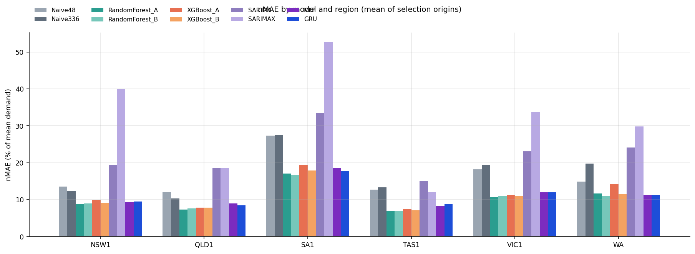
Figure 2. nMAE by model and region (mean of the three selection origins).
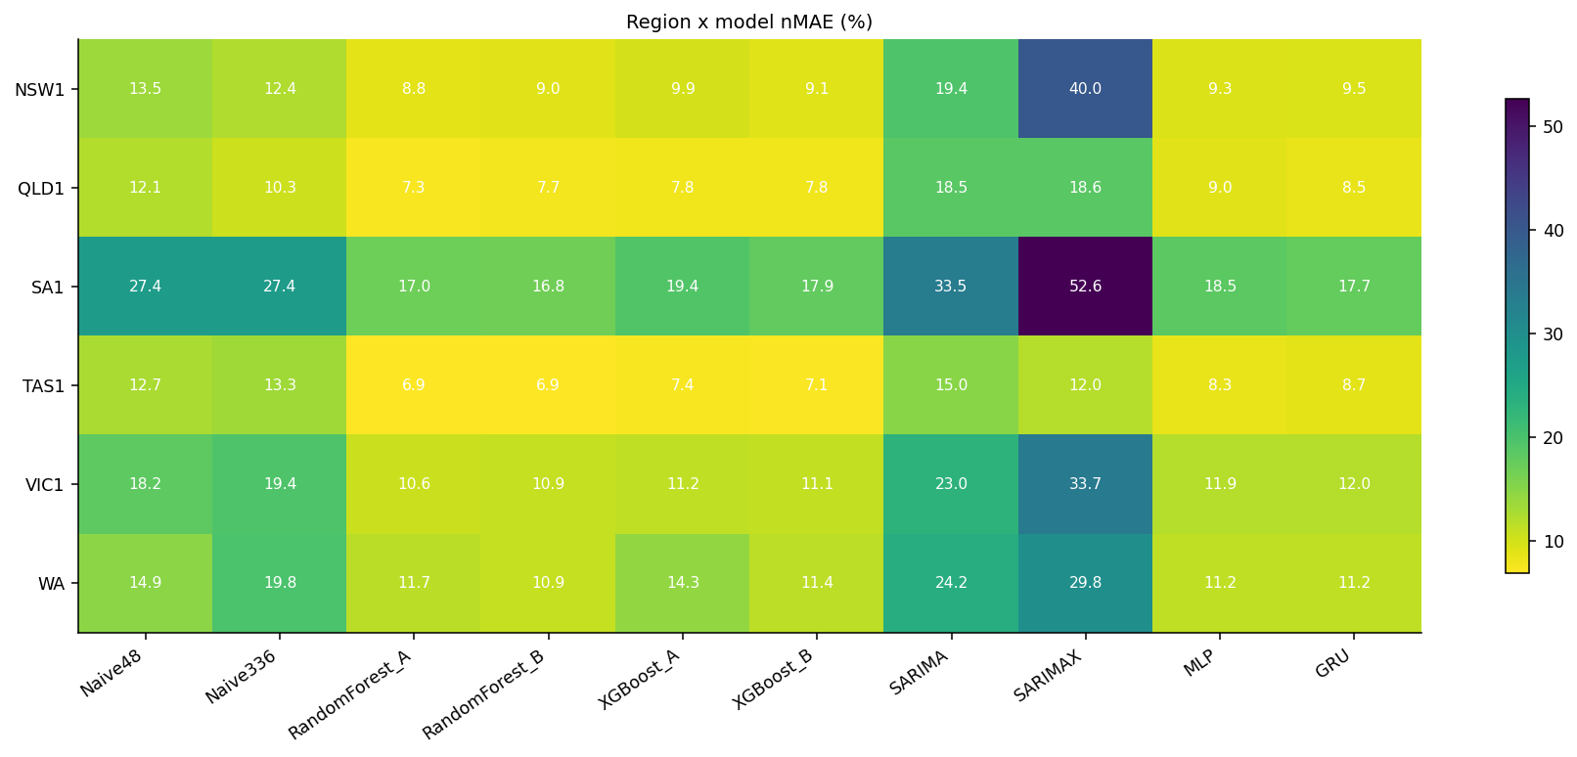
Figure 3. Region × model nMAE heatmap. The two Random Forest columns are the lowest in every row.
The two Random Forests are effectively tied at the top on the cross-region average (10.36% and 10.38% nMAE), followed by XGBoost_B (10.73%). The GRU (11.27%) and MLP (11.37%) come next, ahead of XGBoost_A (11.66%) — so the neural models are competitive with part of the previous ensemble work but not with its best. Every learned model beats both naive baselines (16.4–17.1%) by a wide margin; SARIMA (22.3%) does not, and SARIMAX is not comparable because it only produced forecasts for part of the windows.
Technical interpretation
RandomForest_A and RandomForest_B produced the lowest mean four-month nMAE across the six regions (10.38% and 10.36%), with skill of about 27% over the best naive forecast; MLP and GRU were 0.9–1.0 percentage points worse on average, and no neural model won a region.
Practical / non-technical meaning. Across Australia, the Random Forest forecasts were consistently the closest to the demand that actually happened. The new neural models were reasonable — clearly better than simple repetition of last week — but not as accurate as the model the project already had.

13. Regional Performance
The table below shows the mean four-month MAE in MW for every model and region. Reading along a row shows how a model copes with different demand scales and climates; reading down a column shows how close the competition was in each region.
Table 15. Mean four-month MAE (MW) by model and region, 2023–2025 origins († SARIMAX incomplete coverage; last two rows are non-selection experiments)
Model | NSW1 | QLD1 | VIC1 | SA1 | TAS1 | WA
Naive48 | 926.3 | 727.7 | 781.1 | 304.8 | 132.5 | 279.3
Naive336 | 848.8 | 623.8 | 839.1 | 306.9 | 137.9 | 372.7
RandomForest_A | 604.8 | 438.2 | 457.1 | 189.4 | 70.9 | 219.1
RandomForest_B | 617.4 | 460.7 | 469.1 | 186.4 | 71.6 | 204.5
XGBoost_A | 679.4 | 472.8 | 484.3 | 215.8 | 76.3 | 267.7
XGBoost_B | 623.4 | 470.7 | 477.0 | 199.2 | 73.3 | 214.4
SARIMA | 1,330.7 | 1,112.1 | 993.8 | 373.0 | 155.3 | 453.4
SARIMAX | 2,735.8† | 1,114.3† | 1,416.3† | 587.5 | 130.0† | 563.2†
MLP | 639.9 | 541.2 | 513.4 | 205.4 | 85.5 | 210.7
GRU | 653.0 | 509.5 | 516.1 | 196.7 | 89.6 | 211.1
GRU_L672 | 654.8 | 518.0 | 510.6 | 196.0 | 86.7 | 207.3
XGBoost_A+CoreWeather | 634.9 | 470.2 | 474.1 | 200.0 | 69.4 | 217.4

NSW1 (RandomForest_A, 604.8 MW, nMAE 8.8%) is the largest market; RandomForest_B is 2.1% behind and XGBoost_B 3.1%. QLD1 (RandomForest_A, 438.2 MW, 7.3%) is where the Set A advantage is clearest: 5.1% ahead of RandomForest_B and winner in all three years. VIC1 (RandomForest_A, 457.1 MW, 10.6%) is similar to NSW1, with RandomForest_B 2.6% behind. SA1 (RandomForest_B, 186.4 MW, 16.8%) has the highest relative error of any region because rooftop solar drives midday operational demand close to zero; weather helps slightly and RandomForest_A is only 1.6% behind. TAS1 (RandomForest_A, 70.9 MW, 6.9%) has the flattest load and the smallest margin: RandomForest_B is 1.0% behind, just outside the 1% tie band. WA (RandomForest_B, 204.5 MW, 10.9%) is the only region where a neural model is runner-up (MLP, +3.0%) and where weather has a large effect (Section 18).
Technical interpretation
The winner differs from its runner-up by 1.0–5.1% in MAE. In every region the top two positions are held by Random Forest configurations, except WA where the MLP is second.
Practical / non-technical meaning. In each region the chosen model is the most accurate one tested, but the second-best Random Forest is usually only a few percent behind. That is why the report treats "Random Forest" as the firm decision and the A-versus-B choice as a regional setting.

14. Previous Champion vs MLP vs GRU
This is the central WP4 question: did the models added after the lecturer recommendation improve on the strongest model the project already had? The tables below answer it region by region using neural_vs_previous_comparison.csv; the previous champion is the best of the eight previous models in each region.
Table 16. Strongest previous model vs MLP vs GRU (mean four-month MAE, MW; positive change = neural model worse)
Region | Previous champion | Previous MAE | MLP MAE | MLP change | GRU MAE | GRU change | Best model
NSW1 | RandomForest_A | 604.8 | 639.9 | +5.8% | 653.0 | +8.0% | RandomForest_A
QLD1 | RandomForest_A | 438.2 | 541.2 | +23.5% | 509.5 | +16.3% | RandomForest_A
VIC1 | RandomForest_A | 457.1 | 513.4 | +12.3% | 516.1 | +12.9% | RandomForest_A
SA1 | RandomForest_B | 186.4 | 205.4 | +10.2% | 196.7 | +5.6% | RandomForest_B
TAS1 | RandomForest_A | 70.9 | 85.5 | +20.6% | 89.6 | +26.4% | RandomForest_A
WA | RandomForest_B | 204.5 | 210.7 | +3.0% | 211.1 | +3.2% | RandomForest_B

Table 17. Neural result summary (years better = selection origins in which the neural model had lower MAE)
Region | Previous champion | MLP change | GRU change | MLP better? | GRU better? | DM p-value (MLP / GRU vs champion)
NSW1 | RandomForest_A | +5.8% | +8.0% | No (1/3 years) | No (1/3 years) | p=0.087 / p=0.026
QLD1 | RandomForest_A | +23.5% | +16.3% | No (0/3 years) | No (0/3 years) | p=0.000 / p=0.000
VIC1 | RandomForest_A | +12.3% | +12.9% | No (0/3 years) | No (0/3 years) | p=0.000 / p=0.000
SA1 | RandomForest_B | +10.2% | +5.6% | No (0/3 years) | No (0/3 years) | p=0.000 / p=0.000
TAS1 | RandomForest_A | +20.6% | +26.4% | No (0/3 years) | No (0/3 years) | p=0.000 / p=0.000
WA | RandomForest_B | +3.0% | +3.2% | No (1/3 years) | No (0/3 years) | p=0.032 / p=0.046

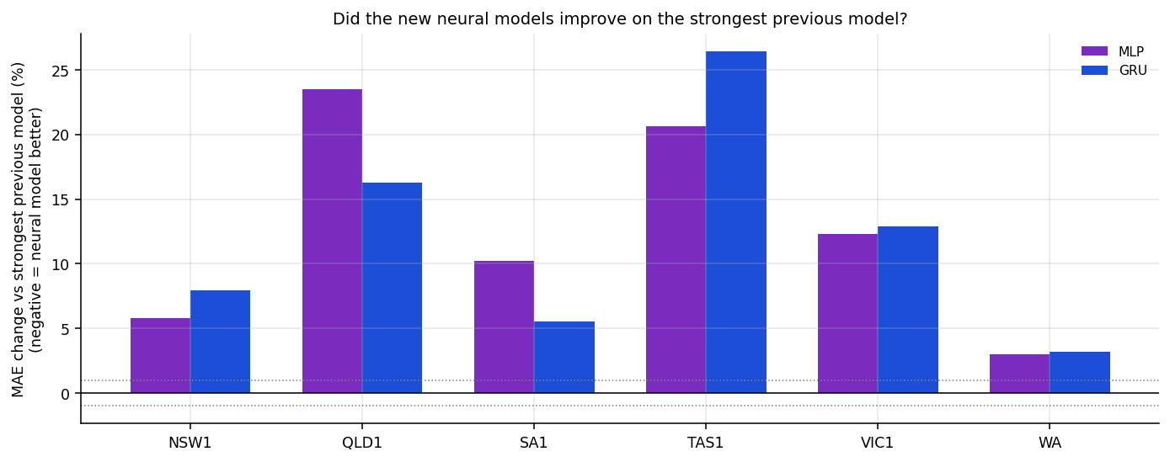
Figure 4. MAE change of MLP and GRU relative to the strongest previous model (negative would mean improvement; dotted lines mark the ±1% tie band).
Neither neural model improved on the previous champion in any region. The MLP was closest in WA (+3.0%) and NSW1 (+5.8%); the GRU was closest in WA (+3.2%) and SA1 (+5.6%). The gaps in QLD1 (MLP +23.5%, GRU +16.3%) and TAS1 (MLP +20.6%, GRU +26.4%) are large. At the level of individual years the picture is only slightly more mixed: the MLP beat the champion in one of three selection years in NSW1 and in WA (WA 2023, where it was the best model of all), and the GRU in one year in NSW1. In the 2022 warm-up the MLP did comparatively better — it was the best model in NSW1 and VIC1 in 2022 — which is interesting but, given the missing profiles in that window, not decision evidence.

14.1 Horizon pattern of the neural gap
Table 18. MAE change of MLP and GRU versus the previous champion by lead band (positive = worse)
Region | MLP Days 1–7 % | MLP Days 8–30 % | MLP Months 2–4 % | GRU Days 1–7 % | GRU Days 8–30 % | GRU Months 2–4 %
NSW1 | +53.6 | +11.9 | +2.7 | +91.0 | +14.7 | +3.3
QLD1 | +39.2 | +51.9 | +19.8 | +32.9 | +34.4 | +13.7
VIC1 | +5.9 | +8.3 | +13.8 | +21.7 | +7.6 | +13.8
SA1 | +13.8 | +9.6 | +10.1 | +18.7 | +8.3 | +4.1
TAS1 | +16.1 | +11.3 | +23.3 | +28.6 | +30.6 | +25.2
WA | +6.6 | +8.4 | +1.8 | +9.9 | +7.4 | +2.0

The neural gap is largest in the first week, not the last three months. In NSW1 the GRU is 91% worse than RandomForest_A in Days 1–7 but only 3.3% worse in Months 2–4; the MLP pattern is the same (53.6% versus 2.7%). WA shows the same narrowing (MLP 6.6% → 1.8%). This contradicts the intuition that a sequence model should be strongest at short range. The explanation is structural: the Random Forest's lag_48, same-half-hour means and month profiles already encode the first days very precisely, while the GRU must reconstruct them from a 336-step window after scaling. Over months 2–4 every model is reduced to profiles and climatology, so the difference in method matters less.

14.2 MLP learning curves
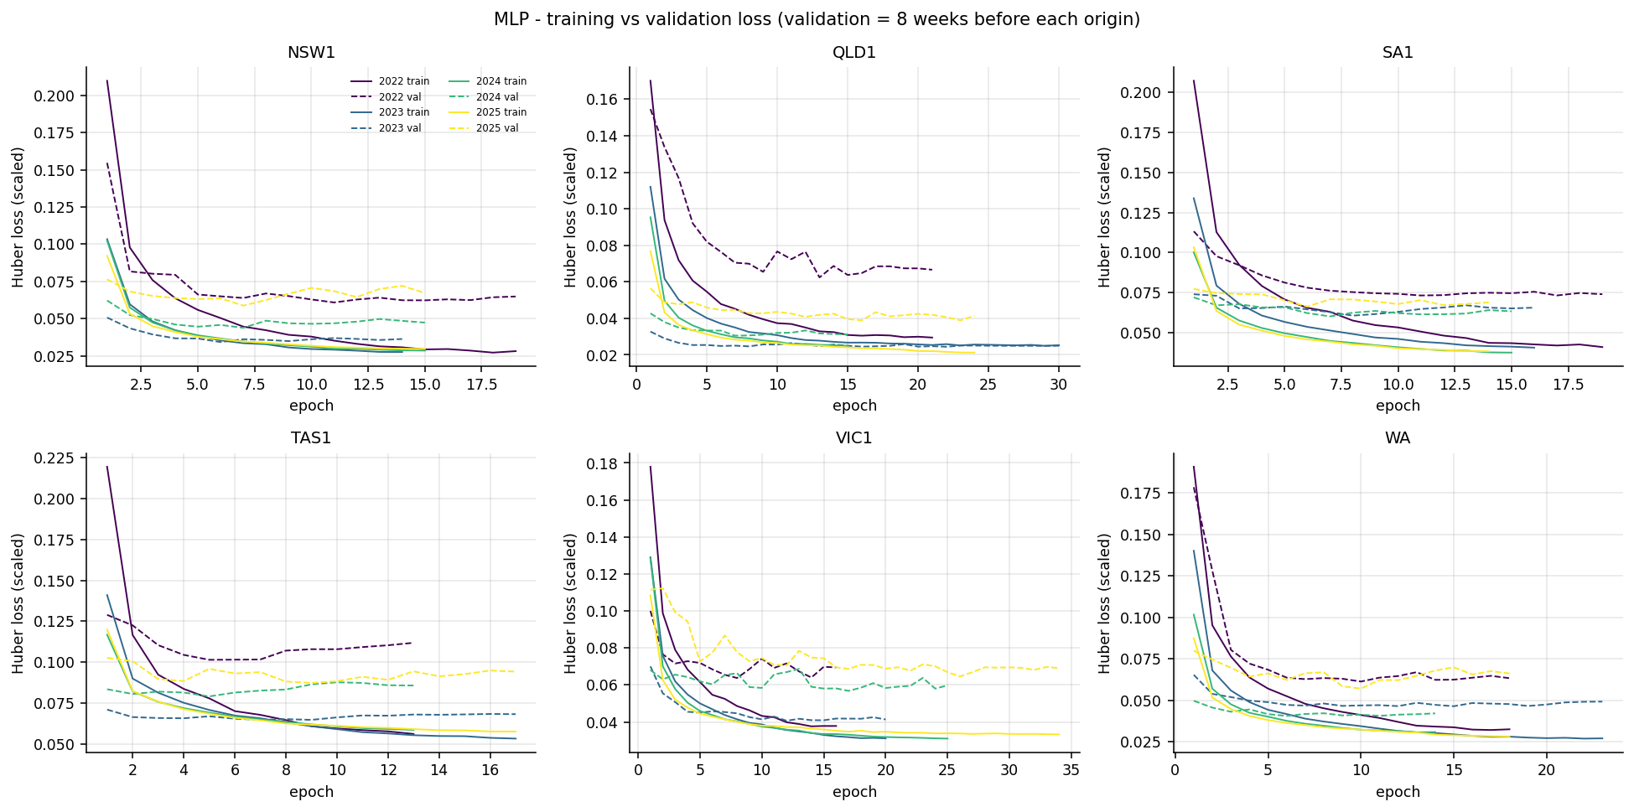
Figure 5. MLP training (solid) and validation (dashed) loss per region and origin; validation = eight weeks before each origin.
The MLP converges quickly. Across the 24 early-stopping fits the best validation epoch has a median of 9 (range 5–26) and early stopping ended every fit well before the 100-epoch limit (mean 18.5 epochs run). The mean gap between validation and training loss at the best epoch is small (0.016 in scaled Huber units). Applying declared rules to the history, 21 fits are classified as converged and 3 show an overfitting signal (validation loss rising more than 10% after its minimum while training loss kept falling). There is no evidence of underfitting, so more epochs would not plausibly help; the limitation is what the network can learn from this representation, not how long it was trained. Low training loss is not evidence of forecasting skill — the validation block is only eight weeks and one step ahead, whereas the test is a four-month recursion.

14.3 GRU learning curves and the 672-step sensitivity
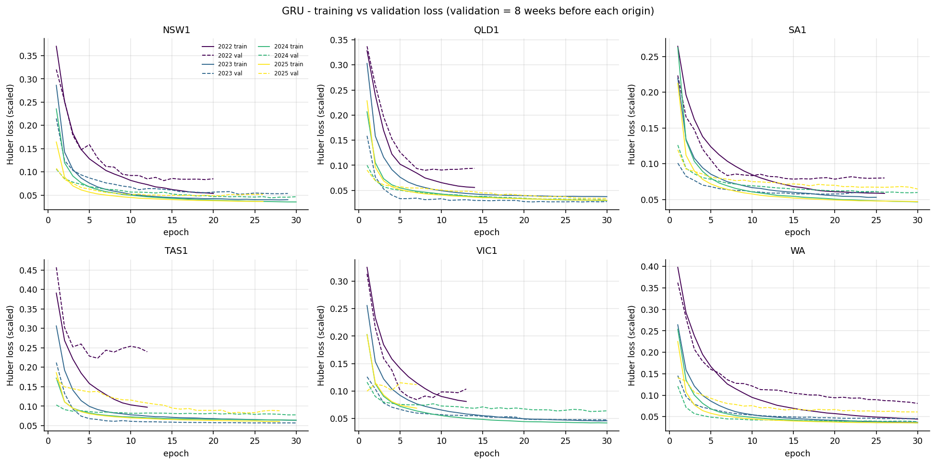
Figure 6. GRU training and validation loss per region and origin.
The GRU learns more slowly. The mean best epoch is 22.6 of a 30-epoch budget and 14 of 24 fits reached the limit with validation loss still at its minimum; the 672-step sensitivity reached it in 17 of 24. The curves are nearly flat over the last ten epochs, so a longer budget would probably reduce validation loss only slightly — and at about 264 seconds per fit already, the cost of finding out is substantial. The 2022 curves are visibly worse and more erratic (little history), and one 2025 VIC1 fit selected epoch 1, a reminder that eight weeks of validation data is a noisy guide.
Doubling the lookback to 14 days changed accuracy by −3.2% to +1.7% across regions (better in SA1, TAS1, VIC1 and WA; worse in NSW1 and QLD1), lowering the cross-region nMAE from 11.27% to 11.18% while taking 2.4 times longer (631 s per fit). It never approached the Random Forest. The sensitivity run therefore answers its own question: a longer memory is not what the GRU was missing.

14.4 Why deep learning did not win
A more complicated model is not automatically more accurate, and the evidence points to several reasons working together.
- The engineered features already carry the temporal information. Recent-demand features and historical profiles account for 70–87% of the selected Random Forests' importance (Section 22). A tree ensemble uses them directly; the GRU has to rediscover them from raw sequences, and the MLP must learn the same interactions with far more parameters than the data comfortably support.
- The horizon is long and recursive. After the first day every model feeds on its own forecasts for 121 more days. Neural outputs are smooth functions that can drift as their inputs drift; tree predictions are bounded by values seen in training, which damps runaway recursion.
- The history is short. Selection origins train on 20 to 44 months. That is small for a sequence model with 20,673 trainable weights (the MLP has 14,977) when each window contains only one or two examples of every September–December season.
- Weather is climatology, not a forecast. In a leakage-safe backtest no model knows the actual future weather, which removes the rich, non-linear signal where a neural network might have an advantage.
- Tabular structure favours trees. Calendar indicators, holidays and profile lookups are heterogeneous tabular features, a setting where tree ensembles are widely reported to remain strong (Grinsztajn et al., 2022).
- Cost without benefit. The GRU needed about 25 times the compute of a Random Forest fit for a worse result (Section 24).
Technical interpretation
Across 18 region-years the MLP beat the previous champion twice and the GRU once; in mean MAE both were worse in all six regions (MLP +3.0% to +23.5%, GRU +3.2% to +26.4%), with Diebold–Mariano p < 0.05 in all six regions for the GRU and in five for the MLP (NSW1 MLP p = 0.087).
Practical / non-technical meaning. We built the more sophisticated neural models the feedback asked for and tested them fairly on the same past periods. They worked, but they were not more accurate than Random Forest, and the deep model was much slower. Finding that out is a valid result: it tells the project not to deploy the more complex option.

15. Historical-Year Stability
A model chosen on a pooled average could hide one bad year. The tables below show nMAE for the leading candidates in every backtest year and which registry model was best in each selection year.
Table 19. nMAE (%) by backtest year (*2022 limited-history warm-up, not used for selection)
Region | Model | 2022* | 2023 | 2024 | 2025
NSW1 | RandomForest_A | 13.54 | 8.66 | 9.03 | 8.72
 | RandomForest_B | 12.89 | 9.58 | 8.54 | 8.85
 | XGBoost_B | 14.74 | 9.88 | 8.55 | 8.79
 | MLP | 11.13 | 9.85 | 8.69 | 9.41
 | GRU | 19.82 | 10.39 | 8.94 | 9.18
 | Naive48 | 13.17 | 12.15 | 12.95 | 15.39
QLD1 | RandomForest_A | 13.40 | 8.02 | 6.26 | 7.57
 | RandomForest_B | 12.81 | 8.29 | 6.67 | 8.01
 | XGBoost_B | 12.52 | 8.53 | 6.82 | 8.12
 | MLP | 14.79 | 9.19 | 7.81 | 9.96
 | GRU | 12.93 | 8.79 | 7.15 | 9.44
 | Naive48 | 7.58 | 10.47 | 9.75 | 15.96
VIC1 | RandomForest_A | 15.64 | 10.71 | 11.27 | 9.87
 | RandomForest_B | 14.85 | 11.12 | 11.21 | 10.35
 | XGBoost_B | 15.72 | 11.10 | 11.63 | 10.50
 | MLP | 13.86 | 12.39 | 12.47 | 10.93
 | GRU | 14.51 | 11.99 | 12.01 | 11.93
 | Naive48 | 18.75 | 24.42 | 13.22 | 16.90
SA1 | RandomForest_A | 22.26 | 17.23 | 17.60 | 16.24
 | RandomForest_B | 22.04 | 18.07 | 17.46 | 14.79
 | XGBoost_B | 24.08 | 19.51 | 18.22 | 16.04
 | MLP | 24.27 | 19.57 | 18.90 | 16.96
 | GRU | 22.91 | 18.85 | 18.22 | 16.03
 | Naive48 | 26.55 | 30.35 | 18.36 | 33.37
TAS1 | RandomForest_A | 8.84 | 5.85 | 6.55 | 8.20
 | RandomForest_B | 8.39 | 6.24 | 6.42 | 8.14
 | XGBoost_B | 9.35 | 6.43 | 7.26 | 7.54
 | MLP | 10.47 | 7.04 | 7.08 | 10.80
 | GRU | 9.32 | 7.05 | 7.26 | 11.87
 | Naive48 | 7.61 | 7.03 | 20.56 | 10.58
WA | RandomForest_A | 21.48 | 11.43 | 10.94 | 12.63
 | RandomForest_B | 19.40 | 11.02 | 10.79 | 10.88
 | XGBoost_B | 17.04 | 12.16 | 11.34 | 10.79
 | MLP | 18.63 | 10.88 | 11.72 | 11.09
 | GRU | 21.29 | 11.07 | 11.28 | 11.40
 | Naive48 | 17.00 | 12.73 | 13.99 | 17.86

Table 20. Best registry model in each selection year
Region | Best in 2023 | Best in 2024 | Best in 2025
NSW1 | RandomForest_A | RandomForest_B | RandomForest_A
QLD1 | RandomForest_A | RandomForest_A | RandomForest_A
VIC1 | RandomForest_A | RandomForest_B | RandomForest_A
SA1 | RandomForest_A | RandomForest_B | RandomForest_B
TAS1 | RandomForest_A | RandomForest_B | XGBoost_B
WA | MLP | RandomForest_B | XGBoost_B

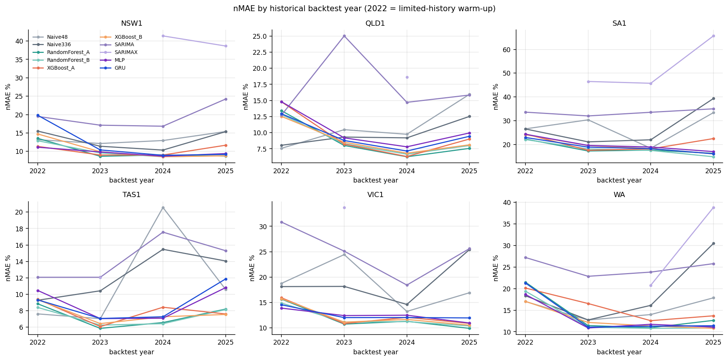
Figure 7. nMAE by historical backtest year for every registry model (2022 = limited-history warm-up).
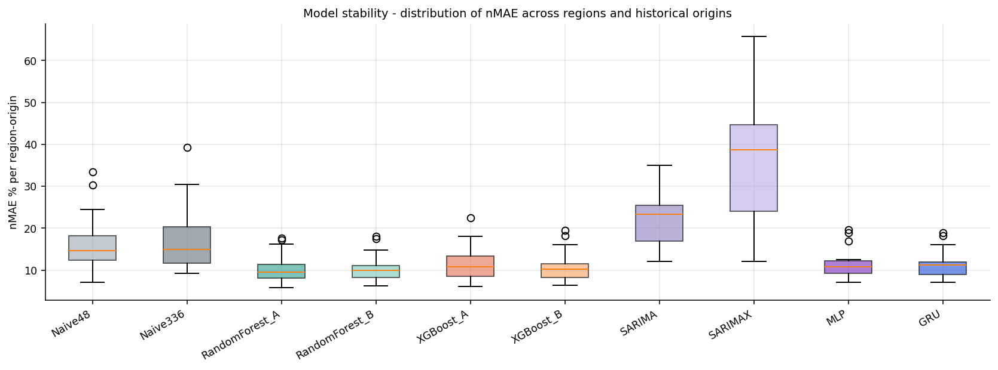
Figure 8. Distribution of region-origin nMAE for each model.
Random Forest configurations were the best model in 15 of the 18 selection region-years (RandomForest_A 9, RandomForest_B 6); XGBoost_B won TAS1 2025 and WA 2025, and the MLP won WA 2023. The winners are also stable: the spread of MAE across the three origins is 3.9 MW for WA, 8.4 MW for TAS1 and 13.8–22.6 MW for NSW1, SA1 and VIC1. QLD1 is the least stable (55.0 MW standard deviation), driven by a harder 2023 window, yet RandomForest_A still won every QLD1 year. The 2022 column behaves differently from the rest — naive repetition was the best model in QLD1, TAS1 and WA that year — which confirms that the limited-history window measures robustness to missing information rather than normal operation.
Technical interpretation
The selected configurations won most individual years and their MAE varied little between years; no winner depends on a single favourable origin.
Practical / non-technical meaning. The chosen model was not lucky once. It was the best, or very close to the best, in each of the three separate years it was tested on.

16. Monthly Stability
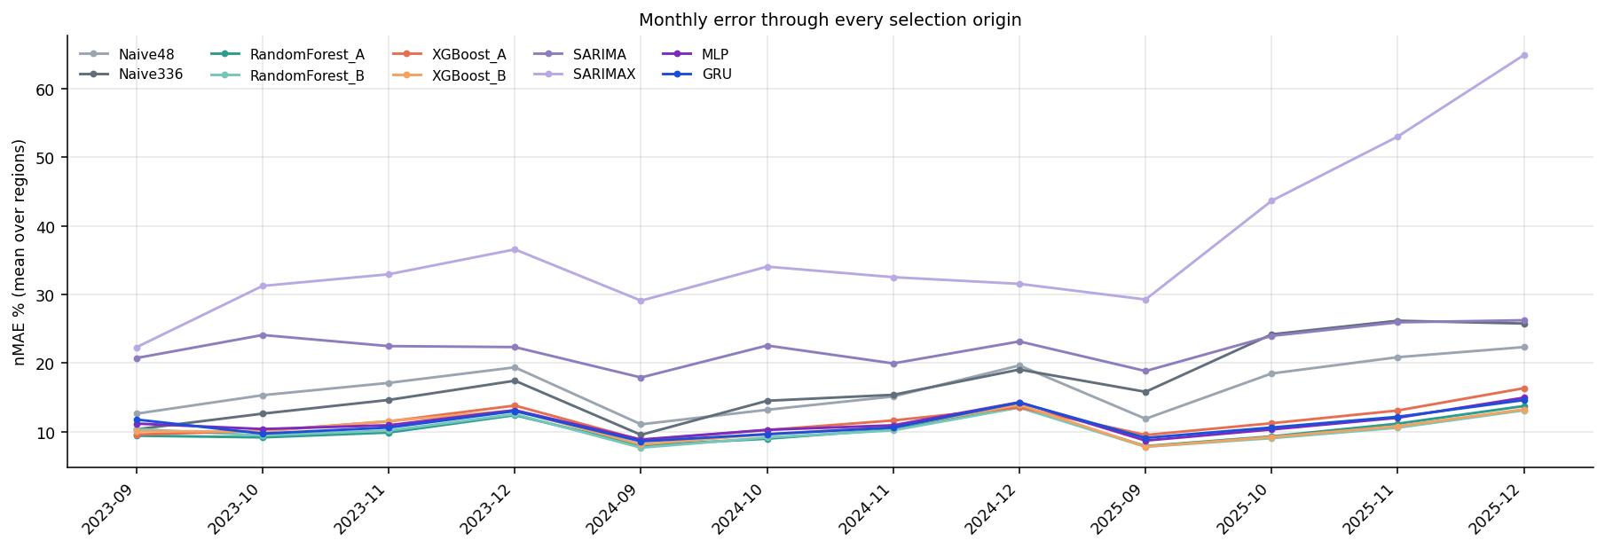
Figure 9. Monthly nMAE through every selection origin (mean over regions).
Error rises through each four-month window, and December is consistently the hardest month. For the selected models the mean nMAE by calendar month is 8.4% in September, 9.2% in October, 10.5% in November and 13.3% in December (RandomForest_A, averaged over regions). December combines the longest lead time, summer heat and the Christmas–New Year shutdown, when commercial load falls in a way that month-level profiles only partly capture. The ordering between models is stable month to month: Random Forest is lowest in every calendar month on average, and the neural models are about 0.7–1.4 points higher throughout.
Technical interpretation
Monthly nMAE for the selected Random Forests rises from about 8% in September to about 13% in December, with the same model ordering in every month.
Practical / non-technical meaning. Forecasts are most accurate for the first month and least accurate for December. The Christmas holiday period is the hardest part of the year to forecast four months ahead.

17. Forecast-Horizon Analysis
A four-month recursive forecast accumulates error: from day 2 onward each model feeds on its own predictions. The table below splits the error into Days 1–7, Days 8–30 and Months 2–4 (mean nMAE over regions).
Table 21. nMAE (%) by lead band, mean over regions (selection origins)
Model | Days 1–7 | Days 8–30 | Months 2–4 | Full horizon | Months 2–4 ÷ Days 1–7
RandomForest_A | 6.95 | 8.93 | 11.02 | 10.38 | 1.58
RandomForest_B | 7.55 | 8.98 | 10.93 | 10.36 | 1.45
XGBoost_A | 7.52 | 9.89 | 12.45 | 11.66 | 1.65
XGBoost_B | 8.07 | 8.88 | 11.42 | 10.73 | 1.41
MLP | 8.45 | 9.96 | 11.98 | 11.37 | 1.42
GRU | 9.17 | 10.05 | 11.75 | 11.27 | 1.28
GRU_L672 | 8.97 | 10.09 | 11.65 | 11.18 | 1.30
Naive48 | 9.80 | 12.55 | 17.99 | 16.45 | 1.83
SARIMA | 12.64 | 21.29 | 23.34 | 22.26 | 1.85

Table 22. Lowest-MAE registry model in each lead band
Region | Days 1–7 | Days 8–30 | Months 2–4 | Full horizon
NSW1 | RandomForest_A | XGBoost_B | RandomForest_A | RandomForest_A
QLD1 | RandomForest_A | RandomForest_A | RandomForest_A | RandomForest_A
VIC1 | XGBoost_A | XGBoost_B | RandomForest_A | RandomForest_A
SA1 | RandomForest_A | RandomForest_A | RandomForest_B | RandomForest_B
TAS1 | RandomForest_A | RandomForest_A | RandomForest_B | RandomForest_A
WA | XGBoost_A | RandomForest_B | RandomForest_B | RandomForest_B

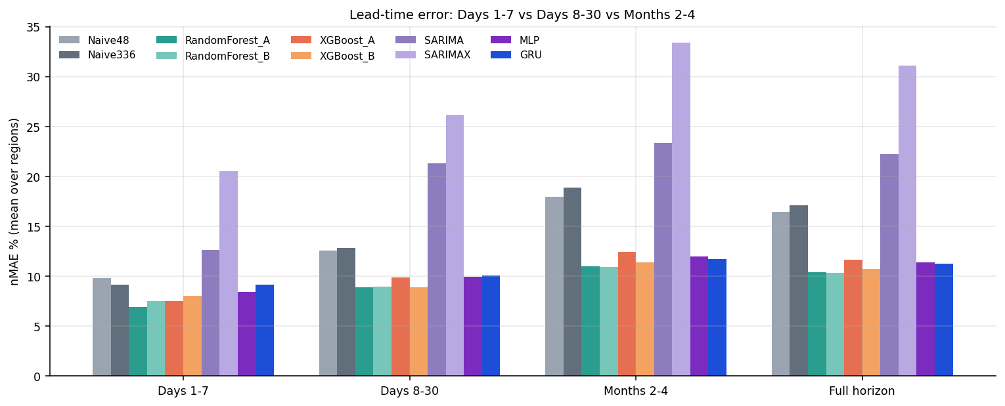
Figure 10. Lead-time error: Days 1–7 vs Days 8–30 vs Months 2–4.
RandomForest_A is the strongest short-term model (6.95% nMAE in Days 1–7, best in four regions; XGBoost_A leads in VIC1 and WA). RandomForest_B is the strongest long-horizon model (10.93% in Months 2–4) and holds the lowest full-horizon error overall. The ranking therefore changes along the horizon: Set A features are enough for the first week, while the weather-context features in Set B add value later. The GRU does not deteriorate faster than the others — its Months 2–4 ÷ Days 1–7 ratio is the lowest of the learned models — but that is because it starts from a much weaker first week, not because it holds up better. The MLP degrades a little more than the GRU. SARIMA collapses after the first week (12.6% → 21.3%), the clearest example of recursive error accumulation.
This is exactly why a four-month production model must not be chosen from Days 1–7 alone. XGBoost_A would win the first week in VIC1 and WA but ranks sixth over the full horizon (11.66%). The portal must deliver the current month plus three months, so the selection metric is the full horizon, with horizon bands used to understand — not to choose — the model.
Technical interpretation
Short-horizon and long-horizon rankings differ; Random Forest is best or near-best in every band, and RandomForest_B is best in Months 2–4 on average.
Practical / non-technical meaning. The model that is best for next week is not always best for three months ahead. Because the project forecasts four months, it picks the model that is most accurate across the whole period.

18. Weather Contribution
Weather was examined with a three-arm XGBoost ablation run on the same origins: XGBoost_A (no weather), XGBoost_A + core weather (Set A plus six direct weather columns) and XGBoost_B (the full 15-column weather context). XGBoost was used because it is the ensemble whose A/B pair is most sensitive to added features; the ablation arm is diagnostic only and never competes for selection.
Table 23. MAE change (%) versus XGBoost_A by lead band (negative = weather helps; weather on the horizon is origin-safe climatology)
Region | A+core D1–7 | A+core D8–30 | A+core M2–4 | A+core Full | B D1–7 | B D8–30 | B M2–4 | B Full
NSW1 | +7.0 | -19.8 | -4.6 | -6.6 | +6.7 | -18.1 | -7.0 | -8.2
QLD1 | +0.6 | -3.9 | -0.2 | -0.5 | -4.1 | -1.3 | -0.2 | -0.4
VIC1 | -0.2 | -9.0 | -0.4 | -2.1 | +4.0 | -7.1 | -0.4 | -1.5
SA1 | +20.2 | -11.9 | -7.7 | -7.3 | +12.4 | -11.2 | -7.9 | -7.7
TAS1 | +3.9 | -6.0 | -10.7 | -9.1 | +4.2 | -2.3 | -4.8 | -3.9
WA | +9.2 | -17.1 | -20.3 | -18.8 | +12.1 | -17.4 | -21.8 | -19.9
Mean | +6.8 | -11.3 | -7.3 | -7.4 | +5.9 | -9.6 | -7.0 | -7.0

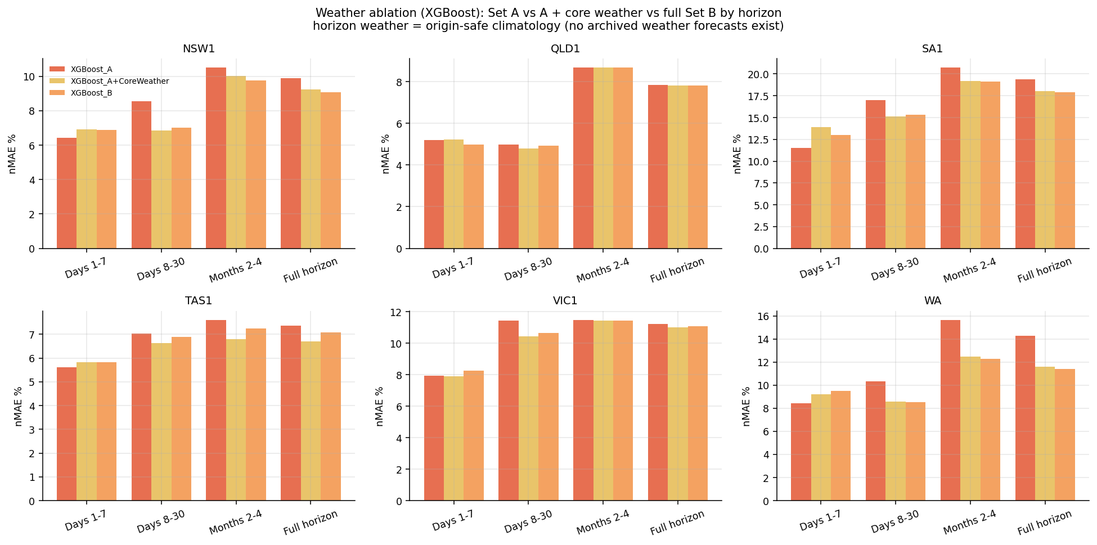
Figure 11. Weather ablation by lead band and region.
Weather does not "work" or "fail" in general; its value depends on horizon and region. In the first week both weather arms are worse than XGBoost_A in five of six regions (means +6.8% and +5.9%): recent demand already reflects the prevailing weather, and substituting a climatological average for the actual week adds noise. From Days 8–30 onward the sign reverses (means −11.3% and −9.6%) and the benefit persists through Months 2–4 (about −7%), because climatology supplies the seasonal warming that lagged demand cannot anticipate. WA gains most (−18.8% and −19.9% over the full horizon) and QLD1 least (about −0.5%).
All historical tests use origin-safe climatology: the average weather for each day of the year and half-hour, built only from years before the origin. This is deliberate. Using the weather that actually occurred would give the backtest information that no forecaster has four months ahead, and would overstate the value of Feature Set B. The experiment therefore measures what weather information is realistically worth at the forecast date — the right question for a portal that forecasts the current month plus three. Genuine forecast weather will add value for the first seven days in production, but that cannot be backtested until archived forecast vintages exist.
One observation is reported for completeness. In TAS1 the ablation arm had a lower mean MAE (69.4 MW) than the selected RandomForest_A (70.9 MW). The arm was declared a diagnostic before the run and is not eligible; promoting it after seeing the result would be selection on the test set. It is recorded as a candidate for a future, pre-registered experiment.
Technical interpretation
Climatological weather increased Days 1–7 error by about 6% on average but reduced Days 8–30 error by about 10% and Months 2–4 error by about 7%, with the largest benefit in WA and almost none in QLD1.
Practical / non-technical meaning. Knowing the typical weather for the time of year helps most when forecasting weeks and months ahead. For next week, recent demand already tells the model most of what it needs. WA benefits most from weather information; Queensland hardly at all.

19. Feature Set A vs B
Table 24. Feature Set A versus B for both tree ensembles (mean four-month MAE, MW; negative = Set B better)
Region | RF_A MAE | RF_B MAE | RF: B vs A | XGB_A MAE | XGB_B MAE | XGB: B vs A
NSW1 | 604.8 | 617.4 | +2.1% | 679.4 | 623.4 | -8.2%
QLD1 | 438.2 | 460.7 | +5.1% | 472.8 | 470.7 | -0.4%
VIC1 | 457.1 | 469.1 | +2.6% | 484.3 | 477.0 | -1.5%
SA1 | 189.4 | 186.4 | -1.6% | 215.8 | 199.2 | -7.7%
TAS1 | 70.9 | 71.6 | +1.0% | 76.3 | 73.3 | -3.9%
WA | 219.1 | 204.5 | -6.7% | 267.7 | 214.4 | -19.9%

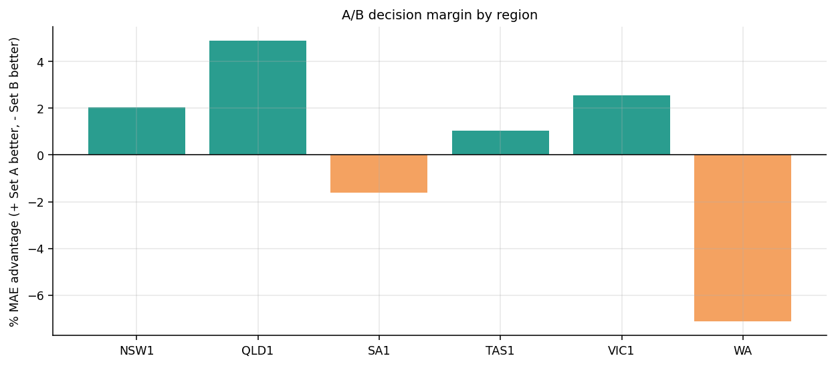
Figure 12. Feature Set A vs B margin for the champion of each family by region.
Set B helps XGBoost in every region but helps Random Forest only in SA1 (−1.6%) and WA (−6.7%). The two learners use extra columns differently. XGBoost fits trees sequentially with no feature subsampling limit per tree, so without weather it must push calendar and profile features to explain seasonal warming and over-fits them; the weather context corrects that. Random Forest already averages 150 de-correlated trees built on random subsets of features, so its Set A version is less exposed, and in NSW1, QLD1, VIC1 and TAS1 the 15 additional, partly redundant columns dilute the strongest splits more than they add information.

19.1 Why Feature Set B only for SA1 and WA?
Three regional factors are consistent with the pattern, although the backtest does not prove causation. WA has a large summer cooling load in an isolated grid, so warming across September–December moves demand more than calendar profiles predict. SA1 demand is dominated by rooftop solar and temperature extremes, which the rain, humidity and degree-day context partly tracks. By contrast QLD1's demand shape changes little across spring, NSW1 and VIC1 are large diversified markets whose recent demand already contains the weather signal, and TAS1's hydro-heated load is flat. The practical lesson is not that one feature set is superior, but that the value of extra weather features is region-dependent and must be earned on out-of-sample data. The margins in SA1 (1.6%) and TAS1 (1.0%) are small enough that the A/B choice could change with more years.
Technical interpretation
Feature Set B lowers Random Forest MAE in SA1 and WA and raises it in the other four regions; for XGBoost it lowers MAE everywhere.
Practical / non-technical meaning. Adding weather information helps some regions and not others, and helps one type of model more than another. The team kept weather where it measurably improved the forecast and left it out where it did not.

20. Peak-Demand Analysis
Peak intervals are defined per origin as the top 5% of pre-origin training demand, so the threshold never uses the test period. Peak MAE, RMSE and Bias measure how far forecasts miss when demand is high. Precision, recall and F1 answer a separate, secondary question — did the model flag the peak days that actually occurred? — and are not measures of forecast accuracy.
Table 25. Peak-demand metrics of the selected models (mean of selection origins)
Region | Model | Threshold MW | Peak intervals | Peak MAE | Peak RMSE | Peak Bias | Daily-peak MAE | Timing MAE (h) | Precision | Recall | F1
NSW1 | RandomForest_A | 8,359 | 698 | 1,143.2 | 1,556.8 | -1,038.9 | 615.3 | 0.70 | 0.40 | 0.12 | 0.12
QLD1 | RandomForest_A | 7,153 | 1,053 | 681.8 | 901.5 | -611.8 | 465.4 | 0.45 | 0.83 | 0.09 | 0.15
VIC1 | RandomForest_A | 5,442 | 641 | 715.4 | 972.3 | -660.7 | 442.6 | 1.81 | 0.75 | 0.16 | 0.24
SA1 | RandomForest_B | 1,557 | 573 | 277.7 | 407.6 | -242.8 | 147.6 | 1.68 | 0.50 | 0.05 | 0.08
TAS1 | RandomForest_A | 1,259 | 234 | 65.5 | 77.5 | -54.7 | 57.6 | 4.13 | 0.75 | 0.31 | 0.35
WA | RandomForest_B | 2,387 | 837 | 417.8 | 566.4 | -381.8 | 239.4 | 0.42 | 0.57 | 0.18 | 0.26

Table 26. Peak metrics averaged over regions
Model | Peak MAE | Peak Bias | Daily-peak MAE | Precision | Recall | F1
RandomForest_A | 541.5 | -485.9 | 326.8 | 0.61 | 0.15 | 0.20
RandomForest_B | 590.2 | -547.8 | 350.9 | 0.57 | 0.09 | 0.14
XGBoost_B | 586.2 | -521.0 | 348.9 | 0.46 | 0.16 | 0.22
MLP | 657.1 | -608.8 | 446.9 | 0.47 | 0.10 | 0.15
GRU | 620.1 | -550.0 | 400.0 | 0.47 | 0.14 | 0.17
Naive48 | 676.3 | -490.4 | 545.4 | 0.11 | 0.24 | 0.04

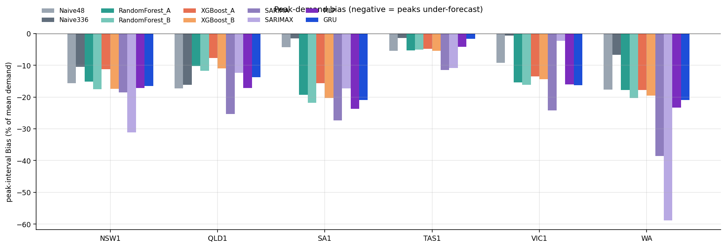
Figure 13. Peak-interval bias by model and region (negative = under-forecast).
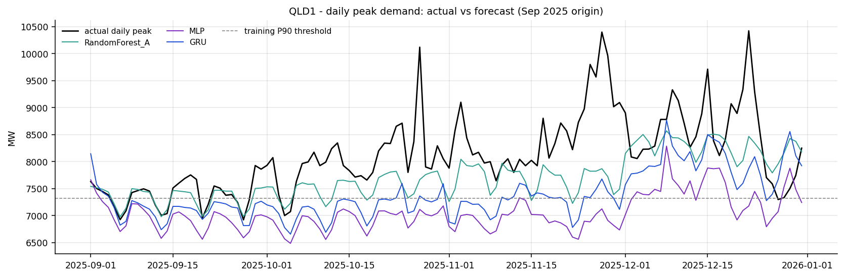
Figure 14. QLD1: actual vs forecast demand in peak intervals (selected model).
Every model under-forecasts peaks in every region. RandomForest_A has the smallest peak MAE on average (541 MW) and the smallest daily-peak error, while MLP (657 MW) and GRU (620 MW) are worse, so the neural models do not recover the extremes that the trees miss. Peak-day recall is low for all learned models (0.09–0.16): forecasts made four months ahead with climatological weather cannot know which specific days will be hot. Precision is higher (0.40–0.83 for the selected models): when a selected model does flag a peak day it is usually right, but it flags too few. Timing is better than magnitude — daily peaks are placed within about 1.5 hours on average — which suggests the shape of the day is right but its height is compressed toward typical values.
Technical interpretation
All selected models have negative peak bias (for example −1,039 MW in NSW1 peak intervals), peak-day recall of 0.05–0.31 (precision 0.40–0.83) and daily-peak timing error of about 1.5 hours.
Practical / non-technical meaning. On the very highest-demand days the forecasts are too low. They get the time of the daily peak roughly right, but not how high it goes. A portal user must not treat the forecast as a peak warning; this is the most important weakness to address next.

21. Residual/Error Analysis
Table 27. Residual structure of the selected models (residual = forecast − actual, MW; residual_analysis.csv)
Region | Worst hour (MAE MW) | Best hour (MAE MW) | Mean residual, lowest-demand decile | Mean residual, highest-demand decile | Mean residual range by weekday
NSW1 | 14:00 (1,047) | 4:00 (233) | +1137 | -1149 | -120 to -14
QLD1 | 14:00 (699) | 4:00 (225) | +470 | -819 | -242 to -140
VIC1 | 14:00 (806) | 4:00 (200) | +1001 | -677 | -7 to +105
SA1 | 13:00 (383) | 2:00 (66) | +425 | -244 | -22 to +75
TAS1 | 13:00 (92) | 0:00 (57) | +154 | -34 | +32 to +54
WA | 15:00 (337) | 5:00 (111) | +202 | -469 | -101 to -34

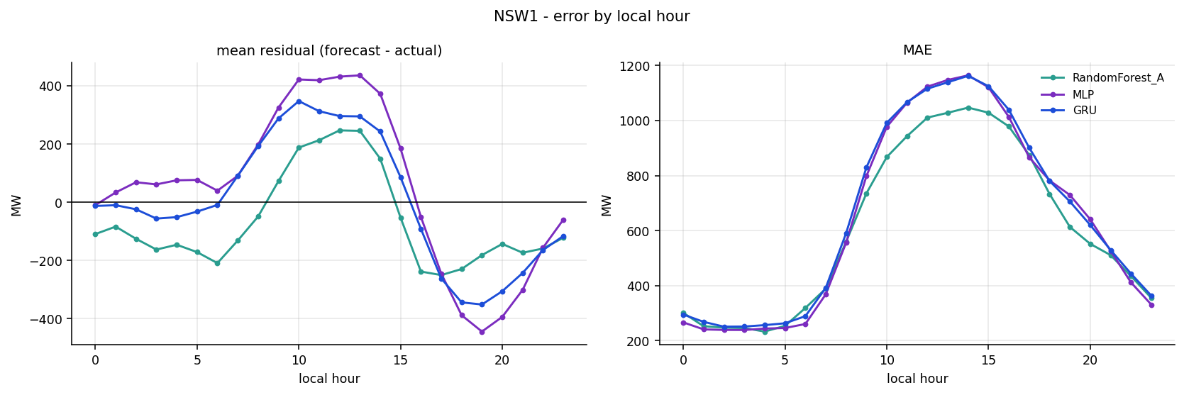
Figure 15. NSW1: MAE and bias by hour of day (selected model).
Three patterns are clear. First, error is highest in the early afternoon (13:00–15:00 local) in every region and lowest overnight: midday demand is where rooftop solar and weather vary most, and where a climatological forecast knows least. Second, the models over-forecast when actual demand is low and under-forecast when it is high — for NSW1 the mean residual is about +1,100 MW in the lowest-demand decile and about −1,100 MW in the highest. Part of this is a statistical artefact of grouping by actual demand (any forecast that is less variable than the outcome shows this pattern), but it is consistent with the peak under-forecasting in Section 20. Third, day-of-week bias is modest and region-specific rather than systematic: QLD1 and WA are below actual on every weekday, TAS1 slightly above. Residual spread also widens as the forecast level rises (R09 plots), a mild heteroscedasticity that matters for any future prediction intervals.
Technical interpretation
Residuals of the selected models are largest at 13:00–15:00, conditionally biased toward the mean (positive at low demand, negative at high demand) and show small region-specific weekday offsets.
Practical / non-technical meaning. The forecasts are least accurate in the middle of the day and tend to be too flat: a little high on quiet days and too low on busy days. Knowing this tells the next phase where to improve.

22. Explainability
Table 28. Grouped feature importance of the selected models (mean over selection origins; feature_importance.csv)
Region | Selected model | Recent demand | Historical profiles | Calendar | Holidays | Trend | Weather
NSW1 | RandomForest_A | 54.2% | 30.2% | 13.7% | 0.2% | 1.7% | 0.0%
QLD1 | RandomForest_A | 53.3% | 30.3% | 14.8% | 0.3% | 1.4% | 0.0%
VIC1 | RandomForest_A | 44.6% | 37.0% | 15.3% | 0.4% | 2.7% | 0.0%
SA1 | RandomForest_B | 33.9% | 36.1% | 11.6% | 0.1% | 1.3% | 17.1%
TAS1 | RandomForest_A | 49.2% | 37.7% | 10.2% | 0.1% | 2.8% | 0.0%
WA | RandomForest_B | 38.5% | 31.8% | 12.8% | 0.1% | 0.9% | 15.9%

Table 29. Top features of the selected models
Region | Four most important features (importance)
NSW1 | lag_48 (0.163); historical_month_dow_halfhour_mean (0.155); same_half_hour_7day_mean (0.105); same_half_hour_14day_mean (0.096)
QLD1 | lag_48 (0.161); historical_month_dow_halfhour_mean (0.151); same_half_hour_7day_mean (0.110); same_half_hour_14day_mean (0.089)
VIC1 | historical_month_dow_halfhour_mean (0.174); same_half_hour_7day_mean (0.101); lag_48 (0.095); historical_month_halfhour_median (0.092)
SA1 | historical_month_dow_halfhour_mean (0.150); historical_month_halfhour_median (0.103); historical_month_halfhour_mean (0.095); lag_48 (0.085)
TAS1 | historical_month_dow_halfhour_mean (0.158); same_half_hour_7day_mean (0.106); same_half_hour_14day_mean (0.102); historical_month_halfhour_median (0.100)
WA | historical_month_dow_halfhour_mean (0.136); lag_48 (0.125); historical_month_halfhour_median (0.087); historical_month_halfhour_mean (0.086)

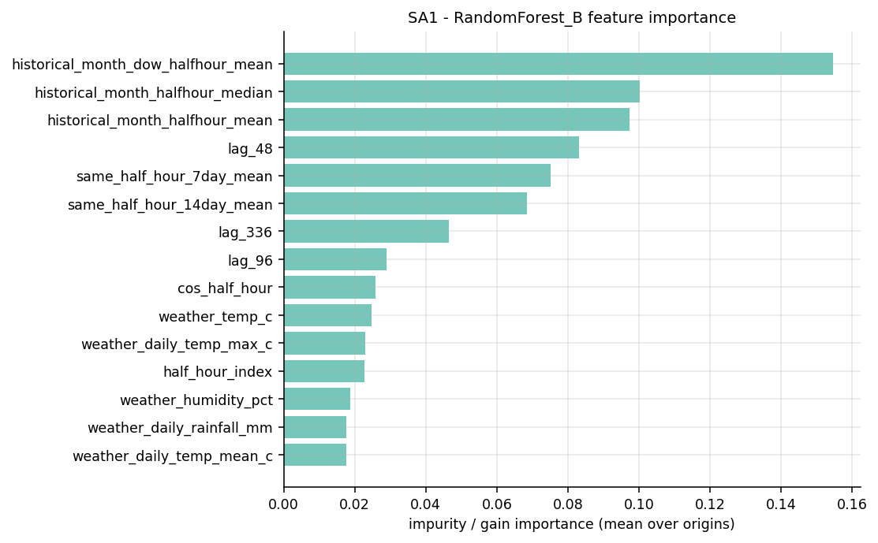
Figure 16. SA1: feature importance of the best tree model (RandomForest_B).
The selected Random Forests rely mainly on what demand did yesterday and last week (lag_48, lag_336, same-half-hour 7- and 14-day means) and on what it typically does in this month, weekday and half-hour (historical profiles). Together these account for 70–87% of importance. Calendar variables add 10–15%; holidays and trend matter little in aggregate because they affect few rows. Weather carries 17.1% of importance in SA1 and 15.9% in WA — the two regions where Set B was selected — which is consistent with the accuracy result.
Importance is not causation. It measures how much the model's internal splits used a feature, and correlated features share or steal importance from each other (lag_48 and the same-half-hour mean contain overlapping information). A high score says "the model found this useful for prediction", not "this variable causes demand".
Technical interpretation
Recent-demand and profile features dominate impurity-based importance (70–87%); weather contributes about 16–17% only in the two Set B regions.
Practical / non-technical meaning. The model forecasts mainly by recognising patterns in past demand — similar days, similar times, similar months. Weather information matters mostly in WA and South Australia. The ranking shows what the model leans on, not what physically causes electricity use.

23. Statistical Comparison
The Diebold–Mariano (DM) test compares the daily MAE series of the selected model and a competitor over the 366 matched days of the three selection windows, with a Newey–West variance to allow for autocorrelation. A small p-value means the difference is unlikely to be chance; it says nothing about whether the difference is large enough to matter.
Table 30. Diebold–Mariano tests: selected model vs runner-up, MLP and GRU (statistical_comparison.csv)
Region | Selected | Compared with | Selected model better by (daily MAE, MW) | DM statistic | p-value
NSW1 | RandomForest_A | RandomForest_B | 12.7 | -0.88 | 0.376
NSW1 | RandomForest_A | MLP | 35.1 | -1.71 | 0.087
NSW1 | RandomForest_A | GRU | 48.2 | -2.22 | 0.026
QLD1 | RandomForest_A | RandomForest_B | 22.5 | -2.56 | 0.011
QLD1 | RandomForest_A | MLP | 103.0 | -7.59 | 0.000
QLD1 | RandomForest_A | GRU | 71.3 | -5.70 | 0.000
VIC1 | RandomForest_A | RandomForest_B | 12.0 | -1.88 | 0.059
VIC1 | RandomForest_A | MLP | 56.3 | -6.34 | 0.000
VIC1 | RandomForest_A | GRU | 59.0 | -6.58 | 0.000
SA1 | RandomForest_B | RandomForest_A | 3.0 | -0.89 | 0.371
SA1 | RandomForest_B | MLP | 19.0 | -9.05 | 0.000
SA1 | RandomForest_B | GRU | 10.4 | -4.09 | 0.000
TAS1 | RandomForest_A | RandomForest_B | 0.7 | -0.84 | 0.400
TAS1 | RandomForest_A | MLP | 14.6 | -7.00 | 0.000
TAS1 | RandomForest_A | GRU | 18.7 | -7.60 | 0.000
WA | RandomForest_B | MLP | 6.1 | -2.15 | 0.032
WA | RandomForest_B | MLP | 6.1 | -2.15 | 0.032
WA | RandomForest_B | GRU | 6.5 | -1.99 | 0.046

Against the neural models the evidence is consistent: the GRU is significantly worse in all six regions and the MLP in five (NSW1 p = 0.087). Against the runner-up Random Forest the picture is weaker. QLD1 (p = 0.010) is clearly in favour of RandomForest_A and VIC1 is borderline (p = 0.060), but in NSW1, SA1 and TAS1 the p-values are 0.37–0.40. The selection rule does not require significance — it chooses the lowest mean MAE outside a 1% tie band — and that is the right design for a practical forecast. The statistics support the family decision strongly and the A/B decision only weakly, which is exactly how this report presents them.
Technical interpretation
DM tests reject equal accuracy between the selected Random Forest and GRU in 6/6 regions and MLP in 5/6; against the runner-up Random Forest they are significant only in QLD1 (and WA vs MLP).
Practical / non-technical meaning. We are confident Random Forest is better than the neural models. We are less certain that version A is better than version B in every region — in several regions the two are nearly equal, which is why either can be served from the same code.

24. Computational Cost
Table 31. Computational cost per region-origin run (computational_cost.csv; 8-core CPU, no GPU)
Model | Mean fit (s) | Mean predict (s) | Mean total per run (s) | Total in full run (min) | Relative to RF_A
RandomForest_A | 4.3 | 5.9 | 10.3 | 4.1 | 1.0×
RandomForest_B | 4.9 | 6.1 | 11.0 | 4.4 | 1.1×
XGBoost_A | 8.6 | 1.6 | 10.3 | 4.1 | 1.0×
XGBoost_B | 11.6 | 1.9 | 13.5 | 5.4 | 1.3×
MLP | 11.6 | 1.0 | 12.7 | 5.1 | 1.2×
GRU | 261.2 | 1.9 | 263.8 | 105.5 | 25.6×
GRU_L672 | 626.9 | 3.3 | 631.0 | 252.4 | 61.3×
SARIMA | — | — | 29.8 | 11.9 | 2.9×
SARIMAX | — | — | 55.4 | 22.2 | 5.4×

The tree models, the MLP and SARIMA all train in seconds per region-origin. The GRU is the outlier: 261 seconds to fit on average (about 25 times a Random Forest run), and 627 seconds for the 672-step sensitivity version. Across the full academic run the GRU pair alone consumed about six hours of the 426.7-minute total. Random Forest prediction is slower than XGBoost (about 6 s versus 1.6 s per four-month recursion) because 150 deep trees must be traversed for every day block, but that is negligible for a monthly portal update.
Speed is not a selection criterion here, and the report would still recommend the GRU if it had been materially more accurate. It was not, and that makes the cost relevant: a monthly retraining cycle for six regions with the GRU would take tens of minutes on CPU (or require a GPU), add a TensorFlow dependency to the portal, and increase failure points, all for a worse forecast. The Random Forest artefacts have their own cost — each saved model is about 260–300 MB because the trees are deep — which the production phase must manage (Section 30).
Technical interpretation
GRU runtime ≈ 264 s per run versus ≈ 10–11 s for Random Forest; neither neural model improved accuracy.
Practical / non-technical meaning. The deep model took about 25 times longer to train and still did not forecast better, so it would make the portal slower and harder to maintain for no gain.

25. Regional Winner Selection
The rule was fixed before the run: among models with full coverage and no warning status on the three selection origins, choose the lowest mean four-month MAE; if others fall within 1% of that value, break the tie by lower worst-origin MAE, then more origin wins, then lower complexity. In all six regions the leader was outside the 1% band of every competitor, so no tie-break was needed (selection_trace.txt). SARIMAX in SA1 and SARIMA in VIC1 were set aside at step 0 because of warning status; neither was near the lead.
Table 32. Final model decision (MW unless stated; mean of 2023–2025 origins; regional_model_winners.csv)
Region | Selected model | Set | MAE | RMSE | sMAPE % | nMAE % | Bias | Runner-up (MAE diff) | Reason retained | Portal implementation
NSW1 | RandomForest_A | A | 604.8 | 891.0 | 9.16 | 8.81 | -67.5 | RandomForest_B (+2.1%) | Lowest MAE; 2.1% ahead of RF_B (DM p=0.38) | models/NSW1/RandomForest_A.joblib; Feature Set A
QLD1 | RandomForest_A | A | 438.2 | 622.2 | 7.52 | 7.28 | -182.1 | RandomForest_B (+5.1%) | Lowest MAE; 5.1% ahead of RF_B (DM p=0.01), won all 3 years | models/QLD1/RandomForest_A.joblib; Feature Set A
VIC1 | RandomForest_A | A | 457.1 | 637.6 | 11.37 | 10.62 | 49.8 | RandomForest_B (+2.6%) | Lowest MAE; 2.6% ahead of RF_B (DM p=0.06) | models/VIC1/RandomForest_A.joblib; Feature Set A
SA1 | RandomForest_B | B | 186.4 | 278.9 | 25.15 | 16.77 | 22.0 | RandomForest_A (+1.6%) | Lowest MAE; 1.6% ahead of RF_A (DM p=0.37) | models/SA1/RandomForest_B.joblib; Feature Set B
TAS1 | RandomForest_A | A | 70.9 | 89.7 | 6.91 | 6.87 | 42.2 | RandomForest_B (+1.0%) | Lowest MAE; 1.0% ahead of RF_B (DM p=0.40) | models/TAS1/RandomForest_A.joblib; Feature Set A
WA | RandomForest_B | B | 204.5 | 307.9 | 11.55 | 10.90 | -73.7 | MLP (+3.0%) | Lowest MAE; 3.0% ahead of MLP (DM p=0.03); lowest spread (sd 3.9 MW) | models/WA/RandomForest_B.joblib; Feature Set B

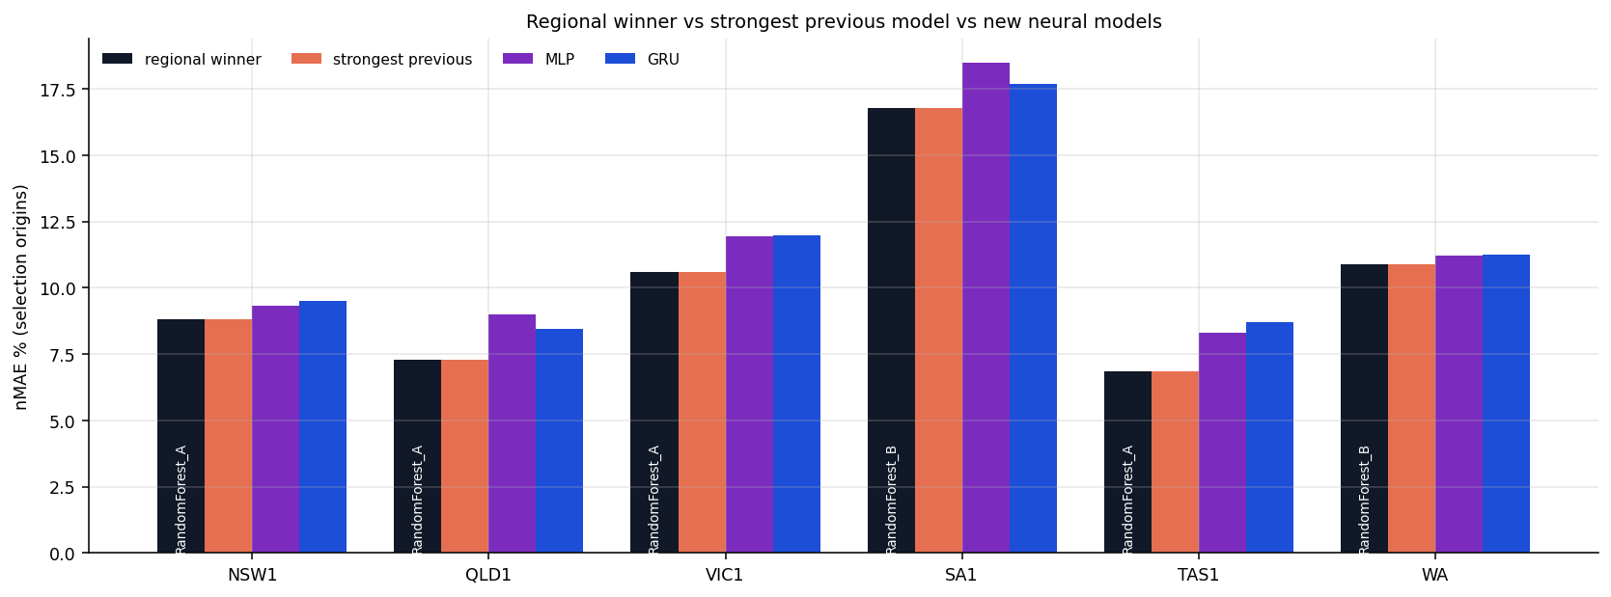
Figure 17. Selected model versus runner-up by region.
The selected models improve on the best naive baseline by 24.9% (SA1) to 32.4% (VIC1), have modest bias relative to demand (the largest is QLD1 at −182 MW, about 3% under actual) and are the most stable candidates in their regions. The TAS1 margin (1.04%) is the narrowest and would have become a tie under a 1.1% tolerance, in which case the tie-break chain would have decided; this is noted rather than hidden.

26. Common vs Regional vs Hybrid Strategy
Table 33. MAE penalty (%) of using one model everywhere versus the regional winner (common_model_comparison.csv)
Model as common choice | NSW1 | QLD1 | VIC1 | SA1 | TAS1 | WA | Mean penalty % | Max penalty %
RandomForest_B | 2.1 | 5.1 | 2.6 | 0.0 | 1.0 | 0.0 | 1.82 | 5.1
RandomForest_A | 0.0 | 0.0 | 0.0 | 1.6 | 0.0 | 7.1 | 1.46 | 7.1
XGBoost_B | 3.1 | 7.4 | 4.4 | 6.9 | 3.5 | 4.8 | 5.00 | 7.4
GRU | 8.0 | 16.3 | 12.9 | 5.6 | 26.4 | 3.2 | 12.06 | 26.4
MLP | 5.8 | 23.5 | 12.3 | 10.2 | 20.6 | 3.0 | 12.58 | 23.5

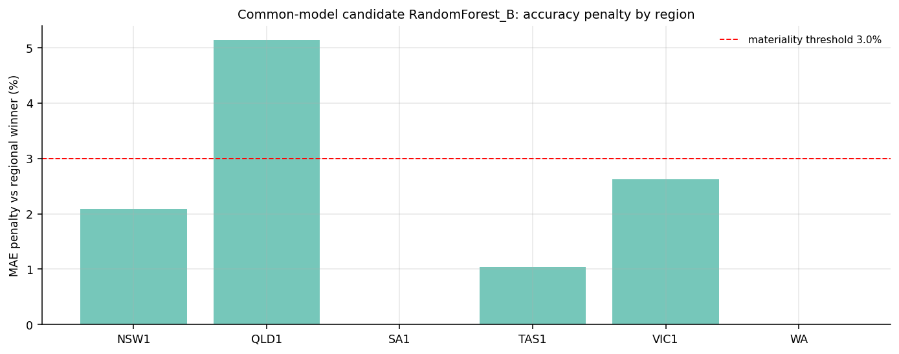
Figure 18. Penalty of the best common model versus regional winners.
RandomForest_B is the best single common choice (mean penalty 1.8%) but would cost QLD1 5.1% — above the declared 3% materiality threshold — and add 2.1–2.6% in NSW1 and VIC1. RandomForest_A as a common model would cost WA 7.1%. The pipeline's rule therefore indicates a hybrid.
Table 34. Deployment strategy comparison
Criterion | A. Regional (each winner) | B. Common (RF_B everywhere) | C. Hybrid (one RF code path, A/B schema per region)
Accuracy | Best in every region | Mean −1.8%, QLD1 −5.1% | Same as regional
Complexity | Low here, because all winners are Random Forest | Lowest | Low
Maintenance | Two feature schemas | One schema | One model class, two schemas
Model artefacts | 6 regional .joblib files | 6 regional files (still one per region) | 6 regional files
Portal implementation | Region lookup of model + schema | Single schema | Region config table: model = RF, set = A/B
Risk | None beyond monitoring | Material accuracy loss in QLD1 | None beyond monitoring; A/B margins small

Because every regional winner is a Random Forest, the regional and hybrid strategies are the same system: one Random Forest implementation whose feature schema (A or B) is a regional configuration value. Convenience does not justify accepting the QLD1 loss of a common RandomForest_B. Recommended strategy: C, hybrid — one Random Forest code path with region-specific A/B feature configuration.

27. Final Model Retention
Final recommendation
Model family retained: Random Forest (150 trees, depth 18; unchanged from WP3).
Regional configuration: RandomForest_A for NSW1, QLD1, VIC1, TAS1; RandomForest_B for SA1 and WA.
Why: lowest mean four-month MAE in every region on three matched full-history origins; best in 15 of 18 region-years; stable across years; significantly better than MLP/GRU; 25–32% better than the best naive baseline; no information advantage.
What does not move forward: MLP, GRU, GRU_L672, XGBoost A/B, the XGBoost weather ablation arm, SARIMA, SARIMAX and the naive baselines. They stay in the research repository as evidence and benchmarks.
Portal consequence: the portal loads six Random Forest artefacts through one code path and a region configuration table; no TensorFlow dependency is needed in production.

27.1 Why keep Random Forest?
Retaining Random Forest is not a failure to adopt deep learning. The deep-learning work was done: an MLP and a GRU were implemented, integrated into the same recursive engine, trained with training-only scaling and chronological validation, and scored on the same held-out September–December windows with the same climatology weather as every other model. Both completed all 24 region-origins. They were then judged by a rule written before the results existed, and neither came within 1% of the previous champion in any region. The Random Forest remained more accurate, more stable, better at peaks and far cheaper to train. Replacing it would make the forecast worse and the system more complex.
In plain terms: the team tried the newer, more sophisticated approach properly, compared it fairly, and kept the approach that forecast better. That is the purpose of an evaluation.

28. Non-Technical Interpretation: What Did We Learn?
We wanted to forecast half-hourly electricity demand for six Australian regions up to four months ahead. After the previous stage, we were encouraged to test whether a more sophisticated kind of model — a neural network — could do better. We tested two: a standard neural network and a "sequence" network designed to read the recent history of demand like a timeline.
To keep the test fair, we pretended to be forecasting in the past. For example, we gave every model only the data available up to 31 August 2023 and asked it to forecast September to December 2023, then compared its forecast with what actually happened. We repeated this for 2024 and 2025, for all six regions. No model was allowed to see the real weather or real demand after the forecast date.
The new models did not automatically become better just because they were more complex. They produced sensible forecasts, but in every region the existing Random Forest model was closer to what really happened. The more advanced sequence model also took about 25 times longer to train.
Random Forest works well here because it already makes strong use of the patterns that matter most: what demand did yesterday and last week, what it usually does at this time of day and year, public holidays, and — in WA and South Australia — typical weather. The selected model is simply the one that was most consistently close to actual demand in periods it had never seen.
The forecasts are not perfect. They are least accurate in the middle of the day and in December, and they tend to be too low on the very hottest, busiest days. People using the future web portal should treat the forecast as a guide to typical demand, not as a warning system for extreme peaks.

29. Team Collaboration
Table 35. Contribution and review structure
Member | Previous stages | WP4 role | WP4 module (Individual_Code/) | Reviewer
Ashish Shrestha | Forecast-safe feature engineering; Random Forest A/B; backtesting; selection | MLP implementation and overall model-selection integration | WP4_Ashish_MLP_Model_Integration.py | Bishal
Bishal Dahal | Validation; baselines; metrics; verification and figures | Independent MLP validation, expanded metrics and evidence | WP4_Bishal_MLP_Validation_Evidence.py | Ashish
Suraj Raut | Timestamp harmonisation; XGBoost; recursive engine and lag provenance | GRU sequence preparation and recursive engine | WP4_Suraj_GRU_Sequence_Engine.py | Sudip
Sudip Lamichhane | WA acquisition; source quality; SARIMA/SARIMAX; weather provenance | GRU training controls, information boundaries and provenance | WP4_Sudip_GRU_Training_Provenance.py | Suraj

The four WP4 modules are current role-aligned collaboration artefacts prepared from the team's integrated implementation for genuine branch-based review and merging; they do not claim or back-date earlier authorship. They share one contract (wp4_contracts.py: ModelInputContract, BacktestContext, NeuralScalerBundle, SequenceBatch, TrainingHistory, ForecastResult, MetricResult), use the pipeline's own constants and metric functions, and each carries equivalence checks against pipeline v4.0.0: the MLP module passes 11/11 (including identical predictions from an identical seed), the GRU sequence engine 14/14 (including a test that a planted horizon actual never enters an encoder window) and the GRU training module 12/12 (including identical trained weights). Bishal's validation module re-derived every published MLP region-year metric from the 1.9-million-row interval detail with a maximum difference of 0.00005.
Review is crossed within pairs (Ashish ↔ Bishal, Suraj ↔ Sudip) and all four review the integration branch. Twelve GitHub issues, labels, a branch and pull-request plan and a gh CLI script are provided for the next collaboration cycle; issue and PR numbers will be assigned by GitHub when the issues are created, and none are claimed here. Because the modules reproduce v4.0.0 behaviour, merging them does not require a rerun; any merge that changes behaviour is labelled rerun-required and invalidates these results for that code until a full academic rerun is completed.

30. Production/Web-Portal Recommendation
The repository and the portal have different jobs. The research/development repository keeps the complete ten-model experiment, all outputs and the evidence trail. The production web portal loads only the retained artefacts listed in models/selected_model.json — six Random Forest models, each refitted on all data to 31 August 2026 — and a region configuration that sets Feature Set A or B.
Table 36. Selected models, month-to-date verification 1–14 September 2026 (production_month_to_date_verification.csv)
Region | Model | Matched intervals | MAE | RMSE | sMAPE % | nMAE % | Bias
NSW1 | RandomForest_A | 625 | 402.1 | 500.8 | 6.31 | 5.84 | 231.9
QLD1 | RandomForest_A | 625 | 178.2 | 280.1 | 3.77 | 3.20 | 39.3
VIC1 | RandomForest_A | 625 | 322.9 | 401.7 | 6.63 | 6.32 | -74.7
SA1 | RandomForest_B | 625 | 162.5 | 249.1 | 20.98 | 13.28 | -4.5
TAS1 | RandomForest_A | 625 | 44.7 | 57.1 | 4.41 | 4.36 | -12.8
WA | RandomForest_B | 640 | 124.3 | 168.0 | 6.44 | 6.11 | 3.8

The first two weeks of the 2026 forecast are in line with the backtests: pooled MAE 205.5 MW over 3,765 intervals (WP3 frozen forecast: 207.3 MW), with every region's nMAE below its backtest average. Two weeks of September is an early indicator only, and September is the easiest month.
- Artefact size. Each joblib artefact is about 260–300 MB (about 1.6 GB for six). The portal should load models lazily per region and store them compressed; reducing tree depth or count would change behaviour and needs a rerun.
- Weather policy. Use genuine forecast weather where available (currently seven days) and origin-safe climatology beyond it; never label climatology as a forecast. This affects only SA1 and WA.
- Monitoring. Publish month-to-date MAE, bias and nMAE; add alerts for sustained bias and for peak under-forecasting.
- Retraining. Monthly, on the previous-month cutoff, using the same selection-free refit of the retained configuration; re-run model selection annually or after a structural change.
- No TensorFlow in production. The neural code stays in research.

31. Limitations
- Peak under-forecasting in every region and low peak-day recall; the forecast is not a peak-warning tool.
- Climatological weather in all backtests: the value of genuine forecast weather in the first week is untested historically.
- Short history. Selection rests on three origins (20–44 months of training data); the 2022 window is information-poor by construction.
- Small A/B margins (1.0–2.6% in four regions, not significant in three) — the A/B assignment could change with more years.
- GRU epoch budget. 14 of 24 GRU fits reached the 30-epoch limit; a longer budget was not tested, although the flat validation curves suggest little gain.
- Two weeks of live verification only.
- Artefact size of about 260–300 MB per Random Forest.
- SARIMAX fragility — 14 failed runs; conclusions about exogenous statistical models are limited.
- DESIGN_CONTROL checks in the leakage audit are enforced by code rather than measured in the run; the WP4 modules add executable tests but those tests are not yet merged into the pipeline.
- No hyper-parameter tuning of any model (deliberately, to avoid tuning on the test windows); a tuned model might perform differently.

32. Next Phase
- Merge the four modules through the 12-issue plan with the equivalence gate (Issues 01–10).
- Write the production hand-off specification and load-test the six artefacts (Issue 12).
- Build the portal path: automated acquisition → preprocessing → region configuration → Random Forest A/B → forecast → verification/monitoring → web portal.
- Start archiving genuine forecast-weather vintages so that Feature Set B can later be backtested with realistic first-week weather.
- Add prediction intervals and a peak-risk indicator, prioritising the midday and top-decile under-forecast.
- Pre-register any further candidate (for example the XGBoost core-weather arm in TAS1) before running it.

33. Conclusion
WP3 established a defensible baseline. WP4 answered the request for stronger modelling by preserving that baseline, consolidating the pipeline, correcting a subtle leakage path, removing a screening step that compromised fairness, and adding an MLP and a GRU that were trained and tested on exactly the same terms as the earlier models. Across 24 region-years and 288 model runs, the evidence is consistent: Random Forest remains the most accurate and stable forecaster in every region, with Feature Set A in NSW1, QLD1, VIC1 and TAS1 and Feature Set B in SA1 and WA. The neural models were valid, reproducible and in WA close, but they did not improve the forecast and the GRU cost far more to run.
The retained model moves to the web portal as one Random Forest code path with regional configuration; everything else stays in the research repository as evidence. The achievement of this phase is a transparent, reproducible and evidence-based model-selection process — one that could have selected a neural model, and did not because the data said otherwise.

References
Breiman, L. (2001). Random forests. Machine Learning, 45(1), 5–32.
Chen, T., & Guestrin, C. (2016). XGBoost: A scalable tree boosting system. Proceedings of the 22nd ACM SIGKDD International Conference on Knowledge Discovery and Data Mining, 785–794.
Cho, K., van Merriënboer, B., Gulcehre, C., Bahdanau, D., Bougares, F., Schwenk, H., & Bengio, Y. (2014). Learning phrase representations using RNN encoder–decoder for statistical machine translation. Proceedings of EMNLP 2014, 1724–1734.
Diebold, F. X., & Mariano, R. S. (1995). Comparing predictive accuracy. Journal of Business & Economic Statistics, 13(3), 253–263.
Grinsztajn, L., Oyallon, E., & Varoquaux, G. (2022). Why do tree-based models still outperform deep learning on typical tabular data? Advances in Neural Information Processing Systems 35 (Datasets and Benchmarks Track).
Hong, T., & Fan, S. (2016). Probabilistic electric load forecasting: A tutorial review. International Journal of Forecasting, 32(3), 914–938.
Huber, P. J. (1964). Robust estimation of a location parameter. The Annals of Mathematical Statistics, 35(1), 73–101.
Hyndman, R. J., & Athanasopoulos, G. (2021). Forecasting: Principles and practice (3rd ed.). OTexts.
Hyndman, R. J., & Koehler, A. B. (2006). Another look at measures of forecast accuracy. International Journal of Forecasting, 22(4), 679–688.
Kingma, D. P., & Ba, J. (2015). Adam: A method for stochastic optimization. International Conference on Learning Representations (ICLR).
Newey, W. K., & West, K. D. (1987). A simple, positive semi-definite, heteroskedasticity and autocorrelation consistent covariance matrix. Econometrica, 55(3), 703–708.
Tashman, L. J. (2000). Out-of-sample tests of forecasting accuracy: An analysis and review. International Journal of Forecasting, 16(4), 437–450.
Project evidence: EnergyForecast_Run_20260929_145931 output package (metrics, validation, explainability, figures, models, environment, summary); Energy_Demand_Forecasting_Pipeline.py v4.0.0; Modelling_Progress_Decision_Updated.py; WP3 Modelling Progress Report; Dan6 Meeting 6 minutes (15 September 2026).

Appendix A – Evidence Register
Each claim below is traceable to a generated file. The full register, the file inventory (38 files with row counts, regions, models and years) and the model completion audit are in Evidence/WP4_Result_Evidence_Register.xlsx.
Table 37. Report evidence table
Evidence claim | Source file | Report section | Technical meaning | Non-technical meaning
All 10 registry models produced scored forecasts; 274 runs OK, 14 failed (all SARIMAX) | run_status.json; model_failures.csv | Model completion audit | Every model competed; failures are recorded, not hidden | Every model was really tried; only one statistical model sometimes broke down
Selection used 2023, 2024, 2025 full-history origins; 2022 limited and reported only | backtest_origins.csv | Historical backtesting | Winner decided on matched out-of-sample windows | The choice is based on three complete autumn-to-summer test periods
RandomForest_A selected in NSW1, QLD1, VIC1, TAS1; RandomForest_B in SA1, WA | regional_model_winners.csv; selection_trace.txt | Regional winner selection | Lowest mean MAE, no other model within 1% | Random Forest was the most accurate in every region
Neither MLP nor GRU improved on the strongest previous model in any region (all changes positive) | neural_vs_previous_comparison.csv | Previous champion vs MLP vs GRU | MLP +3.0% to +23.5%, GRU +3.2% to +26.4% MAE | The new neural models were less accurate everywhere
Closest neural result: WA, MLP +3.0% (runner-up), GRU +3.2% | neural_vs_previous_comparison.csv; regional_model_winners.csv | Previous champion vs MLP vs GRU | Near-competitive in WA only | In WA the neural models came close but still did not win
GRU mean runtime about 264 s per fit vs about 10-11 s for Random Forest | computational_cost.csv | Computational cost | ~25x compute without accuracy gain | The deep model costs far more to run and was not more accurate
RF_A best mean nMAE in Days 1-7 (6.95%); RF_B best in Months 2-4 (10.93%) | model_comparison_by_horizon.csv | Forecast-horizon analysis | Weather-context features help late in the horizon | Weather information matters more for the later months
Weather (XGBoost ablation) raised Days 1-7 error (+5.9% to +6.8% mean) but cut Days 8-30 (-9.6% to -11.3%) and Months 2-4 (about -7%) | weather_ablation_metrics.csv | Weather contribution | Climatological weather helps beyond the first week | Typical-weather information helps longer-range forecasts, not the first week
WA weather benefit largest (about -20% Months 2-4) | weather_ablation_metrics.csv | Weather contribution | Region-dependent weather value | WA benefits most from weather information
All selected models under-forecast peak intervals (negative peak Bias in every region) | peak_demand_metrics.csv | Peak-demand analysis | Systematic peak under-prediction | Very high-demand periods are forecast too low
Winner vs runner-up DM p-values: NSW1 0.376, SA1 0.371, TAS1 0.400 (not significant); QLD1 0.010, WA 0.032, VIC1 0.060 | statistical_comparison.csv; regional_model_winners.csv | Statistical comparison | Margins over the second-best Random Forest are small in several regions | The winner is clearly better than most models, but only slightly better than its closest rival in some regions
RF_B is the best common candidate (mean nMAE 10.357%); one region above the 3% penalty (QLD1 5.1%) | common_model_summary.csv; common_model_comparison.csv | Common vs regional vs hybrid | Hybrid indicated by the declared rule | One model everywhere would cost QLD1 accuracy
Historical profile and recent-demand features dominate importance; weather is 16-17% in SA1/WA | feature_importance.csv | Explainability | Model relies mostly on recent and typical demand patterns | The forecast mainly learns from what demand did recently and in similar past periods
Selected models, 1-14 Sep 2026: pooled MAE 205.5 MW over 3,765 intervals | production_month_to_date_verification.csv | Production verification | Early out-of-sample check consistent with backtests | The first two weeks of real forecasts look reasonable, but it is too early to judge
Leakage audit: 9 PASS, 5 DESIGN_CONTROL; balance point re-derived per origin | leakage_audit.csv; origin_feature_rebuild_checks.csv | Leakage-safe design | No realised future information entered any forecast | Models only used information available at the time the forecast was made
Interval detail reproduces published MLP metrics (max diff 5e-5) | all_models_backtest_detail.csv.gz; model_comparison_by_year.csv | Team collaboration / validation | Result package internally consistent | The summary tables match the raw forecasts
XGBoost_A+CoreWeather ablation arm had lower mean MAE than the TAS1 winner (69.4 vs 70.9 MW) | model_comparison_by_region.csv | Weather contribution | Ablation-only; not eligible by pre-declared design | A test variant did slightly better in Tasmania; it is noted for future work, not selected after the fact

Appendix B – Supplementary Tables
The complete region × model × year table, month and horizon tables, the weather ablation by region and the runtime table are in Evidence/WP4_Final_Model_Comparison.xlsx (7 sheets). The regional winner sheet computes the runner-up MAE difference with live formulas.

Appendix C – Supplementary Figures and Output Inventory
The run produced 107 figures. Those not reproduced here are supplementary evidence in the output package: C01–C03 (MAE, RMSE, sMAPE by model), C09 (error by calendar month), C13 (skill vs naive), C15 (rank by region), C16 (A vs B MAE), S03 (common-model penalty for all models), N03 (GRU_L672 learning curves), and for each region P01 (production forecast) and R01–R13 (full-horizon and daily actual vs forecast, rolling MAE, monthly MAE, scatter, error by hour and weekday, residual distribution, residual vs forecast, peak actual vs forecast, backtest MAE by model, A vs B champions, importance). Figure C1 below is one example.
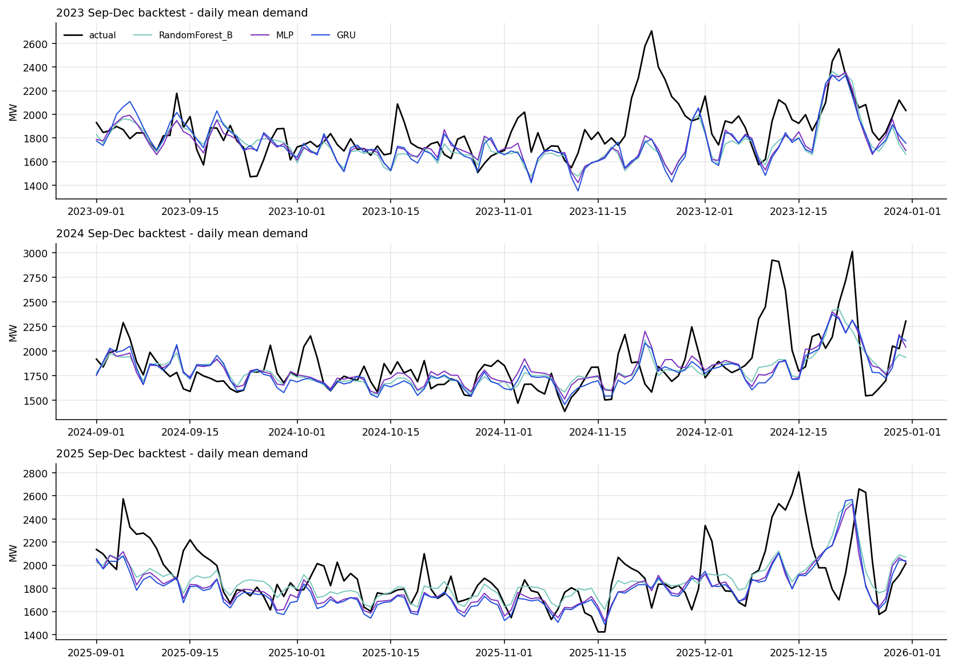
Figure 19. WA: daily actual vs forecast demand across the backtest windows (supplementary example).

